**ABSTRACT**

The business-to-consumer aspect of electronic commerce is the most visible business use of the World Wide Web. The primary goal of an e-commerce site is to sell goods and services online.

Fashionista deals with developing an e-commerce website for online shopping for women. It provides the user with a three main categories: Clothes, Footwear and Accessories, available for purchase in the store. In order to facilitate online purchase a shopping cart is provided to the user. The system is implemented using a 3-tier approach, with a backend database, a middle tier of XAMPP application server and PHP, and a web browser as the front end client.

In order to develop an e-commerce website, a number of technologies must be studied and understood. These include multi-tiered architecture, server and client side scripting techniques, implementation technologies such as PHP, scripting languages (such as JavaScript. jQuery and HTML), relational databases (MySQL).

This is a project with the objective to develop a basic website where a consumer is provided with a shopping cart application and also to know about the technologies used to develop such an application.

**CHAPTER 1 - INTRODUCTION TO COMPANY**

**1.1 PROFILE**

Javonic WebSoft Pvt. Ltd. is a professional and dedicated web designing company having proficiency and experience in designing websites. It is the leading website design firm that provides affordable, professional and practical website design solutions for a new website design or a re-design of an existing website.

Its goal is to provide world best IT Services to everyone whether they are individuals, small & medium business organizations or big corporate houses. Most small to medium sized businesses don't have vast assets for consultants and technology. Javonic Websoft takes a practical approach to all projects it gets and makes an effort to keep costs as low as pragmatically possible.

Its web design online portfolio consists of many different solutions fulfilling diverse needs of its clients. Some of these sites include CMS "Content Management Systems" which allow clients to update and maintain their own web sites or specific pages of their sites. Many of them are designed with specific client requirement’s keeping in mind their demand & their business targets.

**VISION:**

To provide world best IT Services to individuals, small & medium business organizations or big corporate houses.

**MISSION:**

Javonic Websoft understands that each company has its unique requirements from the designing point of view. In spite of the complex functional requirements, it seamlessly fuse eloquent design strategies and aims at high quality, cost effective, mission critical web designing that acts as a bridge between the user and the technology.

From assigning of dedicated team to work on the project, managing communication with customers, and final delivery of the websites, Javonic ensures that individual care is given to each project.

**1.2 AREAS OF WORK**

## Web Development: Javonic WebSoft offers good quality Web Development services to its clients with the best planning and perfect execution laid by professional web application developers.

## Software Development: Javonic WebSoft has the extensive expertise, experience and resources to develop custom software applications.

## Website Design: Javonic WebSoft offers corporate and custom web designs that are user friendly and easily customizable.

* **Domain Registration:** Javonic WebSoft offers registering your domain name like www.yourdomainname.com and make identity online.
* **Web Hosting:** Javonic WebSoft provide Web Hosting for our valuable customer: Windows hosting and Linux hosting.
* **SEO:** Search engine optimization (SEO) is the process of improving the visibility of a website or a web page in a search engine's "natural," or un-paid ("organic" or "algorithmic"), search results. Javonic WebSoft provide Low Cost SEO Service with top rankings guaranteed in a few months.
* **Mobile Application Development**
* **Microsoft Solutions**

**CHAPTER 2 - STUDY CONTENT**

**2.1 INTRODUCTION TO PHP FRAMEWORK**

PHP is a [server-side scripting](http://en.wikipedia.org/wiki/Server-side_scripting) language designed for [web development](http://en.wikipedia.org/wiki/Web_development) and also used as a [general-purpose programming language](http://en.wikipedia.org/wiki/General-purpose_programming_language). While PHP originally stood for Personal Home Page, it now stands for PHP: Hypertext Preprocessor, which is a [recursive](http://en.wikipedia.org/wiki/Recursive_acronym) [backronym](http://en.wikipedia.org/wiki/Backronym" \o "Backronym).

PHP code can be simply mixed with [HTML](http://en.wikipedia.org/wiki/HTML) code or can be used in combination with various [templating engines](http://en.wikipedia.org/wiki/Web_template_system) and [web frameworks](http://en.wikipedia.org/wiki/Web_framework). PHP code is usually processed by a PHP interpreter, which is usually implemented as a web server's native [module](http://en.wikipedia.org/wiki/Plugin_(computing)). After the PHP code is interpreted and executed, the web server sends resulting output to its client, usually in form of a part of the generated web page; for example, PHP code can generate a web page's HTML code, [JSON](http://en.wikipedia.org/wiki/JSON), [XML](http://en.wikipedia.org/wiki/XML) or [binary data](http://en.wikipedia.org/wiki/Binary_data) such as image or audio formats, or some other data.

 PHP can be deployed on most web servers, many [operating systems](http://en.wikipedia.org/wiki/Operating_system) and [platforms](http://en.wikipedia.org/wiki/Computing_platform), and can be used with many [relational database management systems](http://en.wikipedia.org/wiki/Relational_database_management_system) (RDBMS). It is available free of charge, and the PHP Group provides the complete source code for users to build, customize and extend for their own use.

**2.1.1 MVC Architecture:**

MVC or Model-View-Controller is a software architecture or design pattern whose principle is based on the idea that the logic of an application should be separated from its presentation.

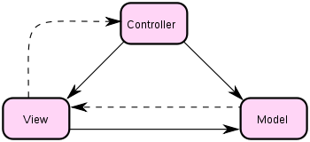

Figure 1: MVC Framework

The MVC principle separates the application into 3 main parts, known as the Model, the View, and the Controller. Apparent from the diagram are the direct associations (solid lines) and the inferred associations (dashed lines). The inferred associations are associations that might seem apparent from the point of view of the user, and not from the actual software design. A simple way to think of this would be to consider the following:

* A user interacts with the view - by clicking on a link or submitting a form.
* The Controller handles the user input, and transfers the information to the model.
* The Model receives the information and updates it's state (say, adds data to a database).
* The View checks the state of the Model and responds accordingly.
* The View waits for another interaction from the user.

.

**2.1.2 Characteristics of PHP**

Five important characteristics make PHP's practical nature possible:

* Familiarity
* Simplicity
* Efficiency
* Flexibility
* Security

**2.1.3 PHP Global Variables - Superglobals**

Several predefined variables in PHP are "superglobals", which means that they are always accessible, regardless of scope - and you can access them from any function, class or file.

Some of the PHP superglobal variables are:

* $_POST: PHP $_POST is widely used to collect form data after submitting an HTML form with method="post". $_POST is also widely used to pass variables.
* $_GET: PHP $_GET can also be used to collect form data after submitting an HTML form with method="get". $_GET can also collect data sent in the URL.
* $_FILES: The $_FILES array is where PHP stores all the information about files. It can be used to upload files.
* $_COOKIE: $_COOKIE retrieves cookies.
* $_SESSION: $_SESSION gives session variable values.

**2.1.4 PHP File** **Inclusion**

You can include the content of a PHP file into another PHP file before the server executes it. There are two PHP functions which can be used to include one PHP file into another PHP file.

* include() function
* require() function

This is a strong point of PHP which helps in creating functions, headers, footers, or elements that can be reused on multiple pages.

**include() function:** The include() function takes all the text in a specified file and copies it into the file that uses the include() function. If there is any problem in loading a file, then the include() function generates a warning but the script will continue execution.

**require() function:** The require() function takes all the text in a specified file and copies it into the file that uses the require() function. If there is any problem in loading a file, then the require() function generates a fatal error and halt the execution of the script.

It is recommended to use require() function to discontinue execution if files are missing.

**2.1.5 PHP Cookies**

A cookie is often used to identify a user. It is a small file embedded by the server on the user's computer. Each time the same computer requests a page with a browser, it sends the cookie too.

**Types of cookies:**

* *Session Cookie:* Also called a *transient cookie*, session cookie is a [cookie](http://www.webopedia.com/TERM/C/cookie.html) that is stored in temporary memory and erased when the user closes the [Web browser](http://www.webopedia.com/TERM/B/browser.html). Session cookies do not collect information from the user’s computer. They typically store information in the form of a session identification that does not personally identify the user.
* *Persistent Cookie:* Also called a *permanent cookie*, or a *stored cookie*, persistent cookie is a [cookie](http://www.webopedia.com/TERM/C/cookie.html) that is stored on a user’s [hard drive](http://www.webopedia.com/TERM/H/hard_drive.html) until it expires (persistent cookies are set with expiration dates) or until the user deletes the cookie. Persistent cookies are used to collect identifying information about the user, such as Web surfing behavior.

With PHP, you can create, modify, delete and retrieve cookie values.

* **Create Cookies:** A cookie is created with the setcookie() function.

**setcookie(name, value, expire, path, domain, secure, httponly);**

* + *name*: Required. Specifies the name of the cookie.
  + *value:* Optional. Specifies the value of the cookie.
  + *expire:* Optional. Specifies when the cookie expires. The value: time()+86400*30, sets the cookie to expire in 30 days. If omitted or set to 0, the cookie will expire at the end of the session (when the browser closes). Default value is 0.
  + *path:* Optional. Specifies the server path of the cookie. If set to "/", the cookie will be available within the entire domain. If set to "/php/", the cookie will only be available within the php directory and all sub-directories of php. The default value is the current directory that the cookie is being set in.
  + *domain:* Optional. Specifies the domain name of the cookie.
  + *secure:* Optional. Specifies whether or not the cookie should only be transmitted over a secure HTTPS connection. TRUE indicates that the cookie will only be set if a secure connection exists. Default is FALSE.
  + *httponly:* Optional. If set to TRUE the cookie will be accessible only through the HTTP protocol (the cookie will not be accessible by scripting languages). This setting can help to reduce identity theft through XSS attacks. Default is FALSE. Example: setcookie("test_cookie", "test", time() + 3600, '/');
* **Retrieve Cookies With PHP:** The value of the cookie is retrieved by using the global variable $_COOKIE. Example: $_COOKIE[“test_cookie”];

## Modify a Cookie Value: To modify a cookie, just set again the cookie using the setcookie() function.

## Delete a Cookie: To delete a cookie, use the setcookie() function with an expiration date in the past.

Example: setcookie test_cookie", "test", time() - 3600);

## Check if Cookies are Enabled: To check whether cookies are enabled count() function is used. Example:

<?php  
 if(count($_COOKIE) > 0) {  
    echo "Cookies are enabled.";  
 }

else {  
    echo "Cookies are disabled.";  
 }  
?>

**2.1.6 PHP Sessions**

When you work with an application, you open it, do some changes, and then you close it. This is much like a Session. The computer knows who you are. It knows when you start the application and when you end. But on the internet there is one problem: the web server does not know who you are or what you do, because the HTTP address doesn't maintain state.

Session variables solve this problem by storing user information to be used across multiple pages (e.g. username, favorite color, etc). By default, session variables last until the user closes the browser. Unlike a cookie, the information is not stored on the user’s computer. A session creates a file in a temporary directory on the server where registered session variables and their values are stored. This data will be available to all pages on the site during that visit.

With PHP, you can start, modify, destroy and get session values.

* **Start a Session:** A session is started with the session_start() function. Session variables are set with the PHP global variable: $_SESSION.

Example: $_SESSION["favcolor"] = "green";

* **Get Session Variable Values:** Session variables are not passed individually to each new page, instead they are retrieved from the session we open at the beginning of each page. Also notice that all session variable values are stored in the global $_SESSION variable:

Example: $_SESSION[“favcolor”].

## Modify a Session Variable Value: To change a session variable, just overwrite it with the new value.

## Destroy a Session: To remove all global session variables and destroy the session, use session_destroy().

**2.3 INTRODUCTION TO XAMPP**

**2.3.1 XAMPP**

XAMPP is a [free and open source](http://en.wikipedia.org/wiki/Free_software) [cross-platform](http://en.wikipedia.org/wiki/Cross-platform) [web server](http://en.wikipedia.org/wiki/Web_server) [solution stack](http://en.wikipedia.org/wiki/Solution_stack) package, consisting mainly of the [Apache HTTP Server](http://en.wikipedia.org/wiki/Apache_HTTP_Server), [MySQL](http://en.wikipedia.org/wiki/MySQL" \o "MySQL) [database](http://en.wikipedia.org/wiki/Database), and [interpreters](http://en.wikipedia.org/wiki/Interpreter_(computing)) for scripts written in the [PHP](http://en.wikipedia.org/wiki/PHP) and [Perl](http://en.wikipedia.org/wiki/Perl) [programming languages](http://en.wikipedia.org/wiki/Programming_language).

XAMPP's name is an [acronym](http://en.wikipedia.org/wiki/Acronym_and_initialism) for:

* X (to be read as "cross", meaning [cross-platform](http://en.wikipedia.org/wiki/Cross-platform))
* [Apache HTTP Server](http://en.wikipedia.org/wiki/Apache_HTTP_Server)
* [MySQL](http://en.wikipedia.org/wiki/MySQL)
* [PHP](http://en.wikipedia.org/wiki/PHP)
* [Perl](http://en.wikipedia.org/wiki/Perl)

Officially, XAMPP's designers intended it for use only as a development tool, to allow website designers and programmers to test their work on their own computers without any access to the Internet. In practice, however, XAMPP is sometimes used to actually serve web pages on the [World Wide Web](http://en.wikipedia.org/wiki/World_Wide_Web). XAMPP also provides support for creating and manipulating databases in MySQL and SQLite among others.

**2.3.2 MySQL**

**2.3.2.1 Introduction**

MySQL is an open source database management system. It is the world's second most widely used [relational database management system](http://en.wikipedia.org/wiki/Relational_database_management_system) (RDBMS) and most widely used open-source RDBMS.

**2.3.2.2 MySQL Architecture**

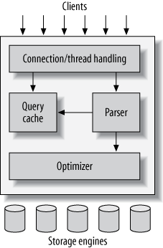

Figure 2: MySQL server architecture

* The topmost layer contains the services that aren’t unique to MySQL. They’re services most network-based client/server tools or servers need: connection handling, authentication, security, and so forth.
* The second layer has much of MySQL’s brains, including the code for query parsing, analysis, optimization, caching, and all the built-in functions (e.g., dates, times, math, and encryption). Any functionality provided across storage engines lives at this level: stored procedures, triggers, and views, for example.
* The third layer contains the storage engines. They are responsible for storing and retrieving all data stored “in” MySQL. Like the various file systems available for GNU/Linux, each storage engine has its own benefits and drawbacks. The server communicates with them through the *storage engine API*. This interface hides differences between storage engines and makes them largely transparent at the query layer. The API contains a couple of dozen low-level functions that perform operations such as “begin a transaction” or “fetch the row that has this primary key.” The storage engines don’t parse SQL or communicate with each other; they simply respond to requests from the server.

**2.3.2.3 Database Connectivity:**

To connect PHP to MySQL database you need to know following important things:

1. Host name (localhost)
2. MySQL user name.
3. MySQL password.

The default MySQL user is "root" while there is no default MySQL password.

**PHP MySQLi functions:** PHP MySQLi = PHP MySQL Improved!

* **Opening connection with database:** The mysqli_connect() function opens a new connection to the MySQL server and returns an object representing the connection.

**mysqli_connect(host,username,password,dbname,port,socket);**

* + *host:* Optional. Specifies a host name or an IP address
  + *username*: Optional. Specifies the MySQL username
  + *password:* Optional. Specifies the MySQL password
  + *dbname*: Optional. Specifies the default database to be used
  + *port:* Optional. Specifies the port number to connect to the MySQL server
  + *socke*t: Optional. Specifies the socket or named pipe to be used.
* **Executing queries:** The mysqli_query() function performs a query against the database. For successful SELECT, SHOW, DESCRIBE, or EXPLAIN queries it will return a mysqli_result object. For other successful queries it will return TRUE, FALSE on failure.

**mysqli_query(connection,query,resultmode);**

* + *connection:* Required. Specifies the MySQL connection to use
  + *query:* Required. Specifies the query string
  + *resultmode:* Optional. A constant. Either:
    - MYSQLI_USE_RESULT (Use when retrieving large amount of data).
    - MYSQLI_STORE_RESULT (This is default).
* **Retrieving values from result set:** The mysqli_fetch_assoc() function fetches a result row as an associative array with database column names as key values.

**mysqli_fetch_assoc(result);**

* + *result:* Required. Specifies a result set identifier returned by mysqli_query(), mysqli_store_result() or mysqli_use_result().

**CHAPTER 3 - REQUIREMENT ANALYSIS**

**3.1 HARDWARE ENVIRONMENT**

|  |  |  |
| --- | --- | --- |
| **S. No.** | **Hardware** | **Requirement** |
| 1 | Processor | Speed more than 1GHz |
| 2 | Monitor | Resolution greater than 1024X768 |
| 3 | Mouse | Standard Mouse |
| 4 | Keyboard | Standard Keyboard |
| 5 | RAM | 512MB RAM |
| 6 | HDD | 2GB HDD |
| 7 | GUI | Standard GUI |

TABLE 1: HARDWARE REQUIREMENTS

**3.2 SOFTWARE ENVIRONMENT**

|  |  |  |
| --- | --- | --- |
| **S. No.** | **Software** | **Requirement** |
| 1 | Software IDE | Sublime Text, XAMPP Server |
| 2 | Web Server | XAMPP Server |
| 3 | Web Browser | IE, Chrome, Firefox, Safari, Opera |
| 4 | Operating System | Windows XP and above |

TABLE 2: SOFTWARE REQUIREMENTS

**3.3 TECHNOLOGIES USED**

|  |  |  |
| --- | --- | --- |
| **S. No.** | **Software Interface** | **Technologies Used** |
| 1 | Front end | HTML, CSS, jQuery, JSON |
| 2 | Server Side Scripting | PHP, |
| 3 | Database | MySQL |

TABLE 3: TECHNOLOGIES USED

**CHAPTER 4 - DIAGRAMS**

**4.1 DATA FLOW DIAGRAMS**

The logic dataflow diagrams can be drawn using only four simple notations i.e., special symbols or icons and the annotation that associates them with a specific system.

**SYMBOLS USED IN DFD:-**

* **BUBBLE** = A bubble is used to depict a process. Both input and outputs to a process are dataflows.
* **ARROW** = Dataflows are represented by a line with an arrow.
* **RECTANGLE** = It is used to represent the entities and are outside the system. Designers do not have any control over them.
* **PARALLELLINES** = It is used to depict data stores. Process may store or receive data from data stores.

**Level 0 DFD**

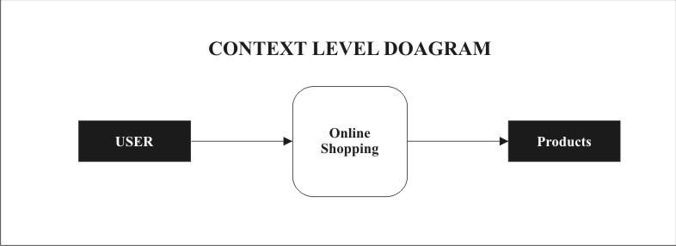

Figure 3: Level 0 DFD for User

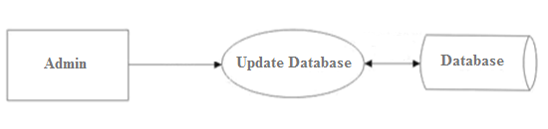

Figure 4: Level 0 DFD for Admin

**Level 1 DFD**

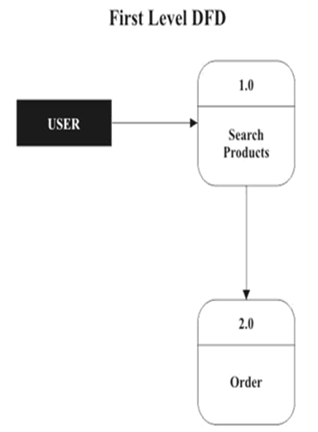

Figure 5: Level 1 DFD for User

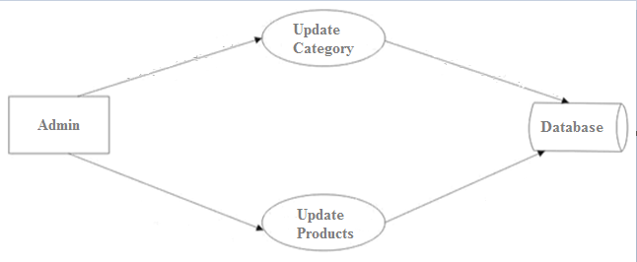

Figure 6: Level 1 DFD for Admin

**Level 2 DFD**

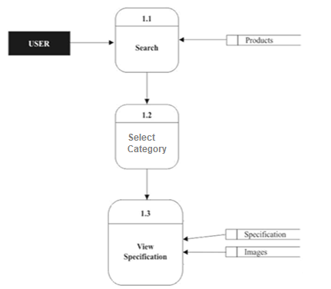

Figure 7: Level 2 DFD for Product Search

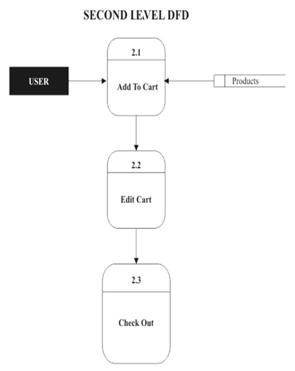

Figure 8: Level 2 DFD for Cart

**5.2 Use Case Diagrams**

This section lists use cases or scenarios from the use-case model which depict significant, central functionality of the final system, or if they have a large architectural coverage.

**Use case for login:**

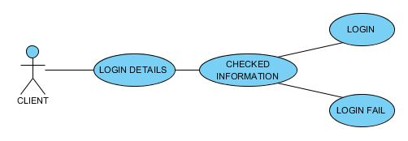

Figure 9: Use Case for Login

**Use case for Sign Up:**

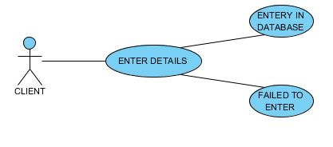

Figure 10: Use Case For Signup

**Use case for Shopping Items**

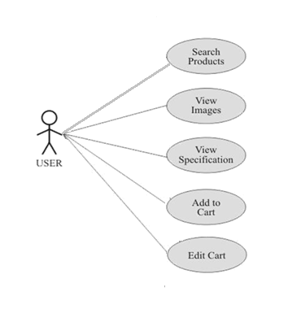

Figure 11: Use Case For Shopping Items

**Use case for Checkout**

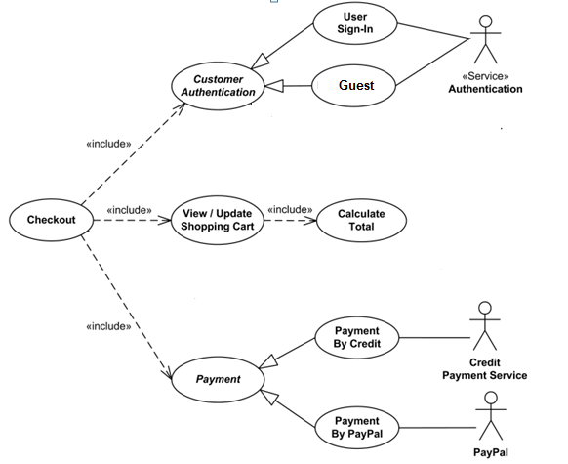

Figure 12: Use Case For Checkout

**CHAPTER 5 - SNAPSHOTS**

**5.1 WEBSITE SNAPSHOTS**

**5.1.1 HOME PAGE**

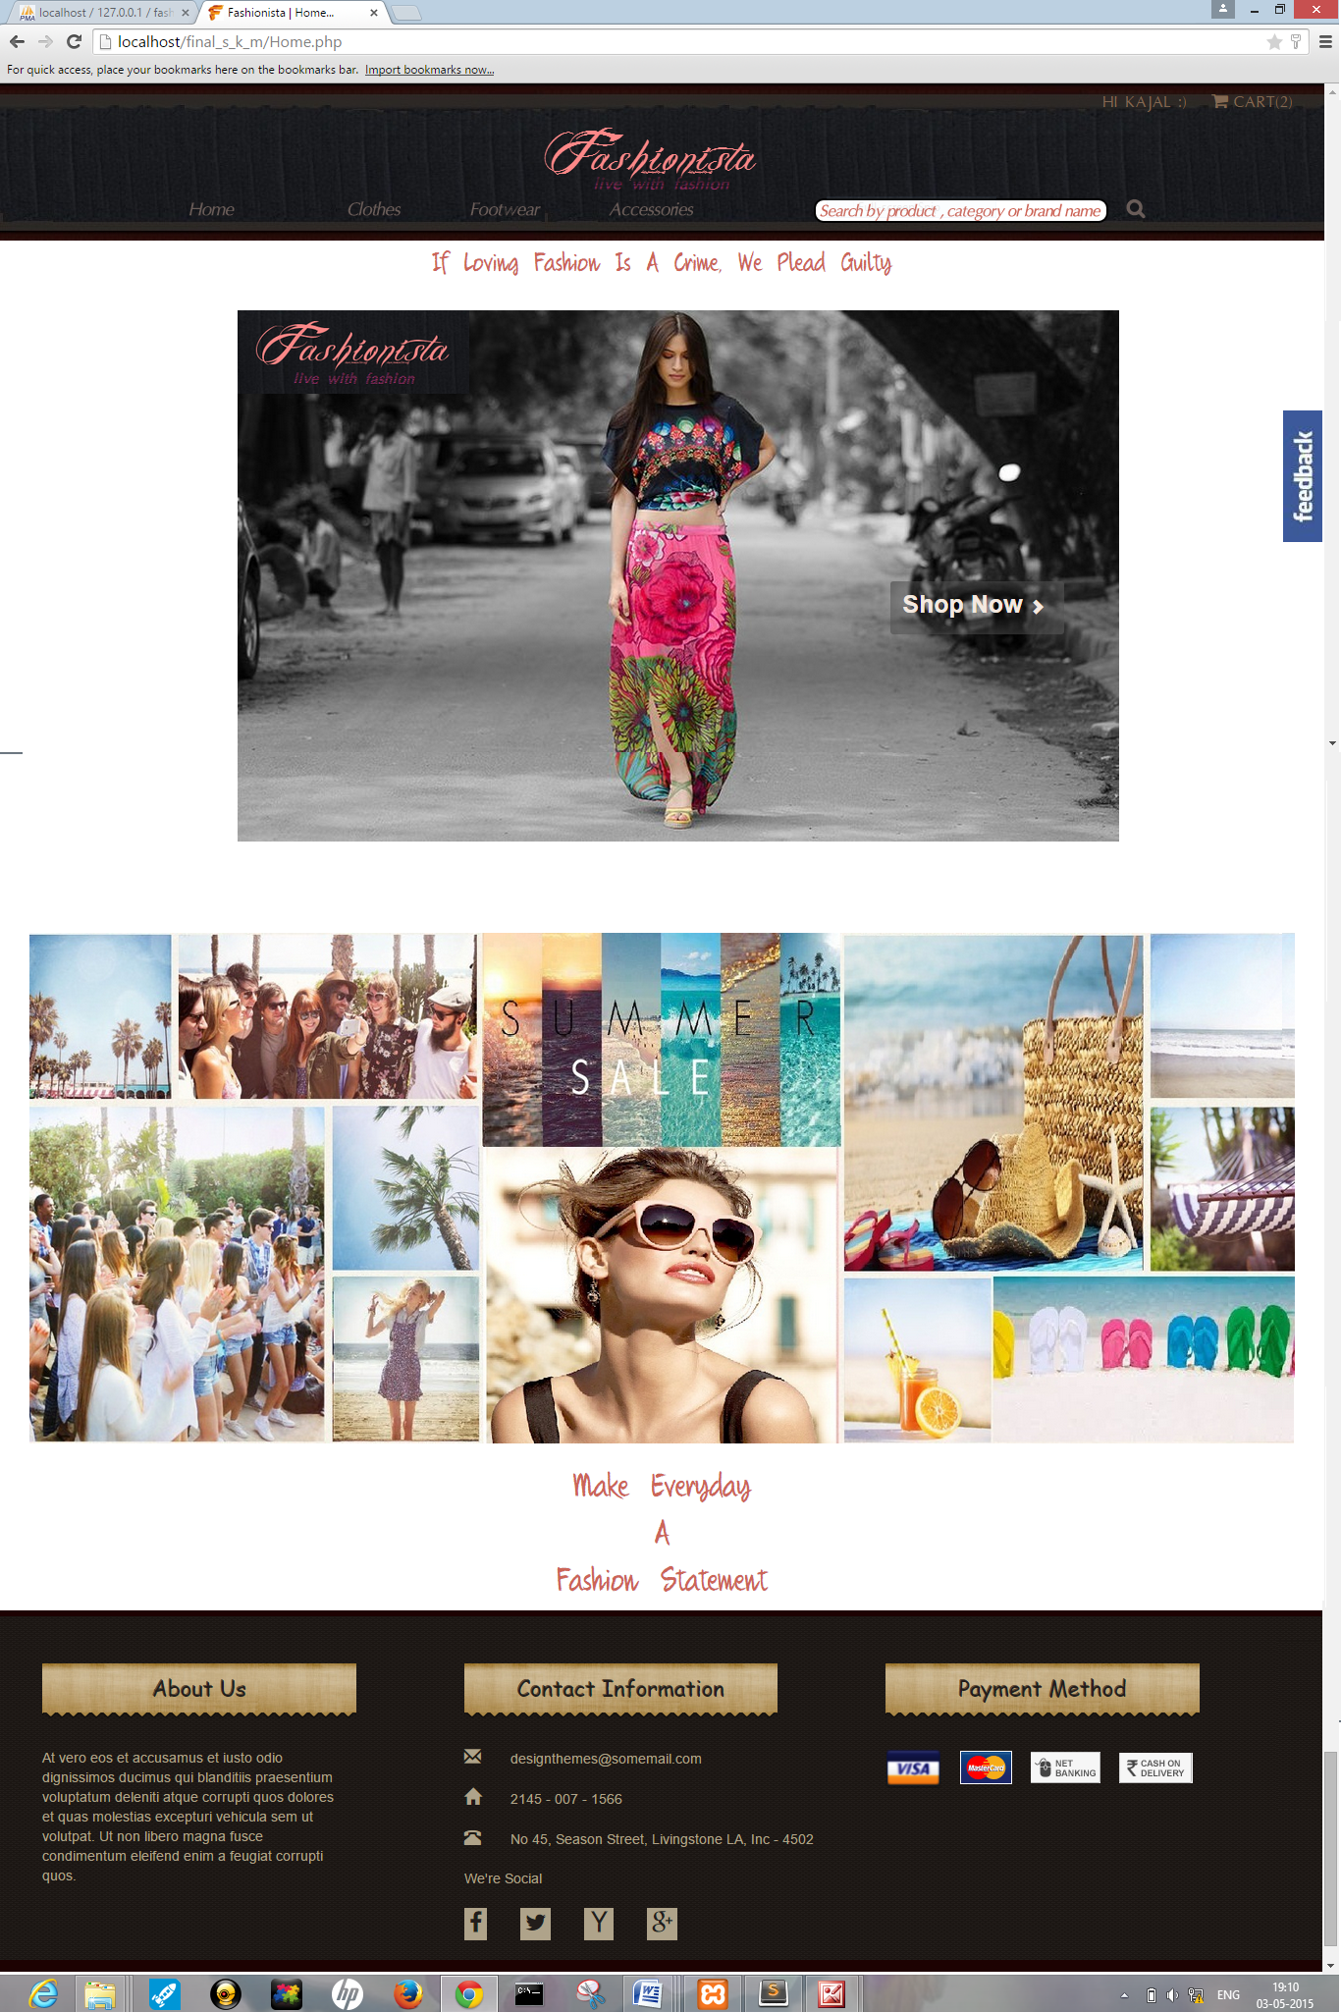

**5.1.2 SIGN UP**

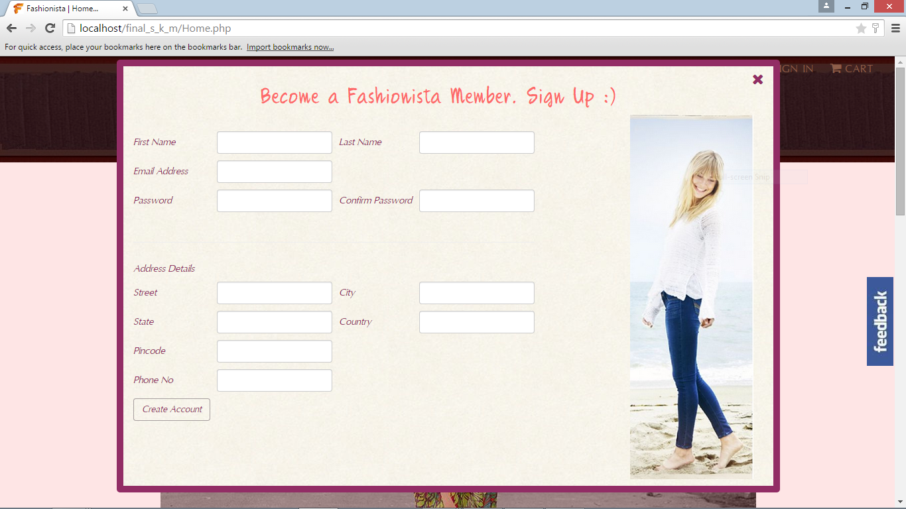

**Insert query for customer sign up on clicking “Create Account”:**

$obj = new DBConnect();

$query = "Insert into `customer` (`customer_fname`, `customer_lname`, `customer_email_id`, `customer_phone_no`, `customer_password`, `customer_street`, `customer_city`, `customer_state`, `customer_country`, `customer_pincode`) values ('$customer_fname','$customer_lname','$customer_email_id','$customer_phone_no','$customer_password','$customer_street','$customer_city','$customer_state','$customer_country','$customer_pincode')";

$obj->sql_update($query);

**5.1.3 LOGIN**

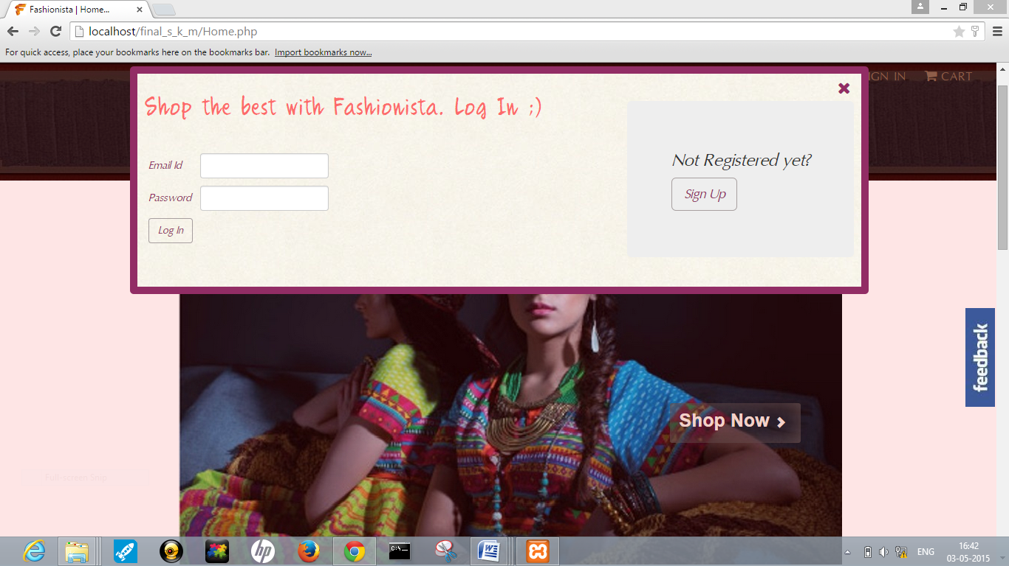

**5.1.4 Customer Account Page:**

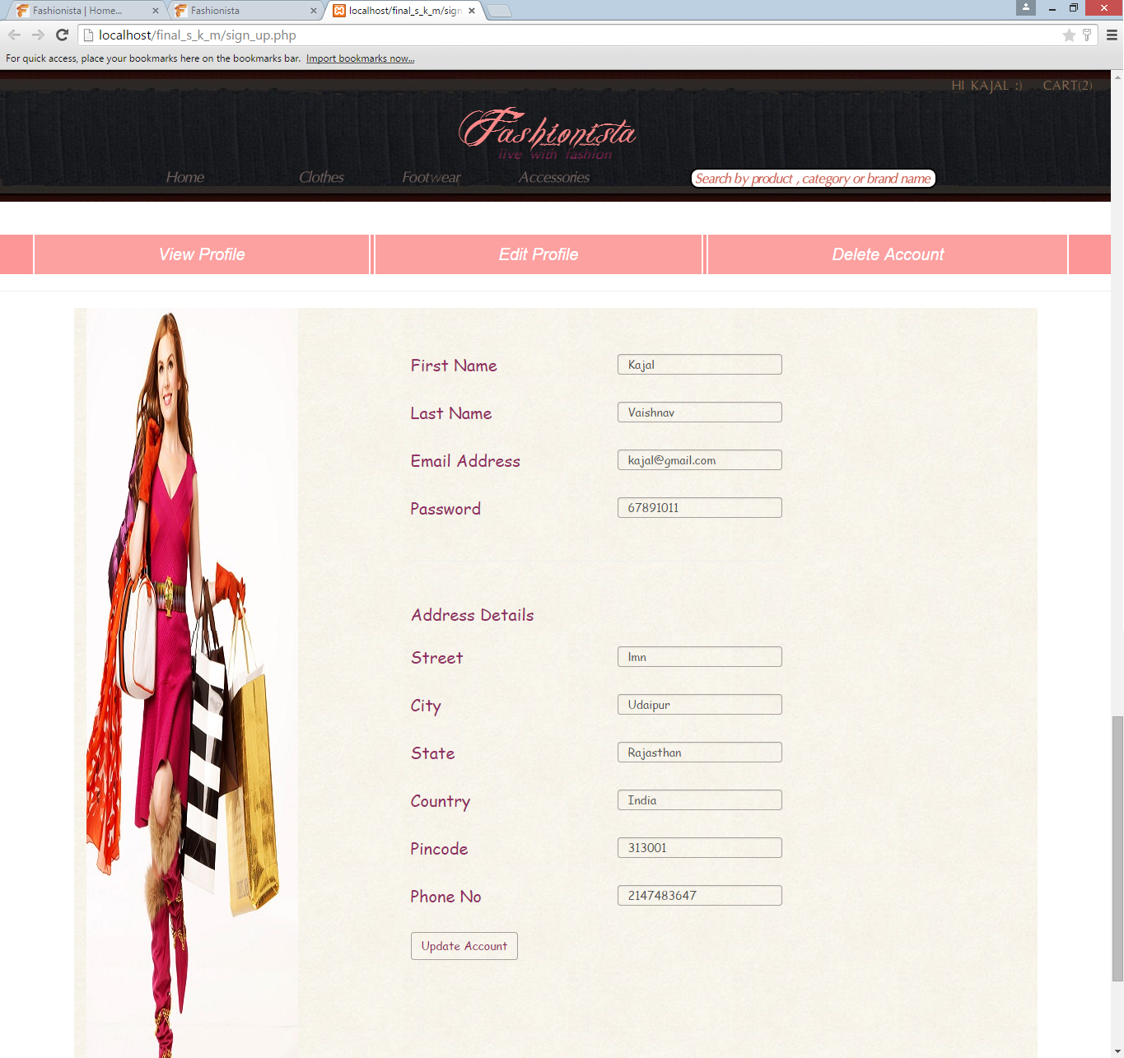

**Update query for customer information on clicking “Update Account”:**

$obj = new DBConnect();

$query = "Update `customer` set `customer_fname`='$customer_fname', customer_lname`='$customer_lname', `customer_email_id`='$customer_email_id', `customer_phone_no`='$customer_phone_no', customer_password`='$customer_password', `customer_street`='$customer_street', `customer_city`='$customer_city', `customer_state`='$customer_state', `customer_country`='$customer_country', `customer_pincode`='$customer_pincode' where `customer_id`='$_SESSION[customer_id]'";

$obj->sql_update($query);

**5.1.5 CLOTHES**

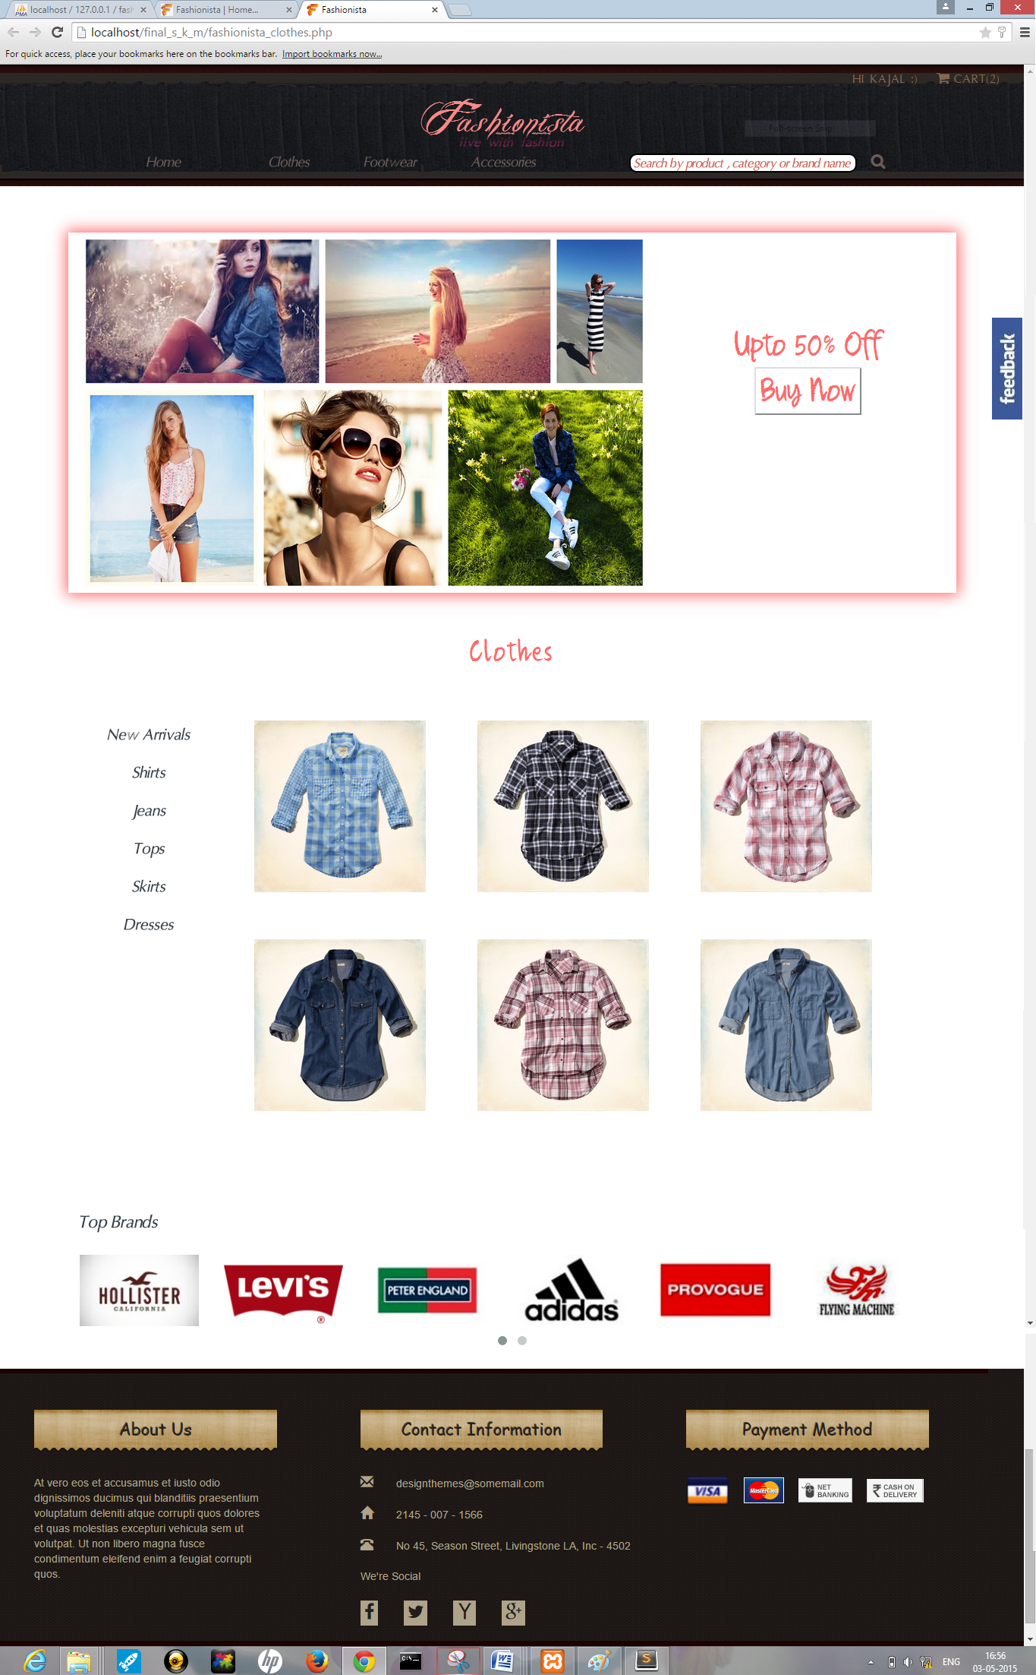

**5.1.6 FOOTWEAR**

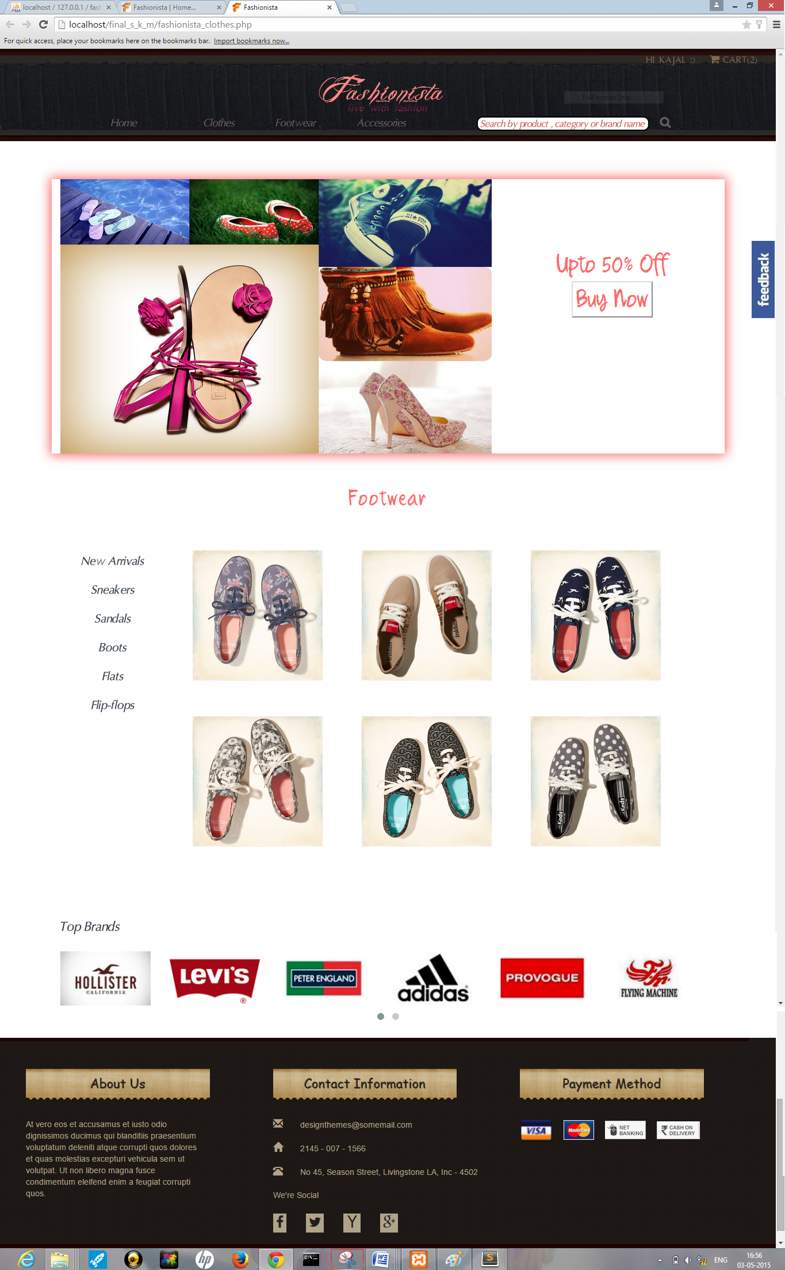

**5.1.7 ACCESSORIES**

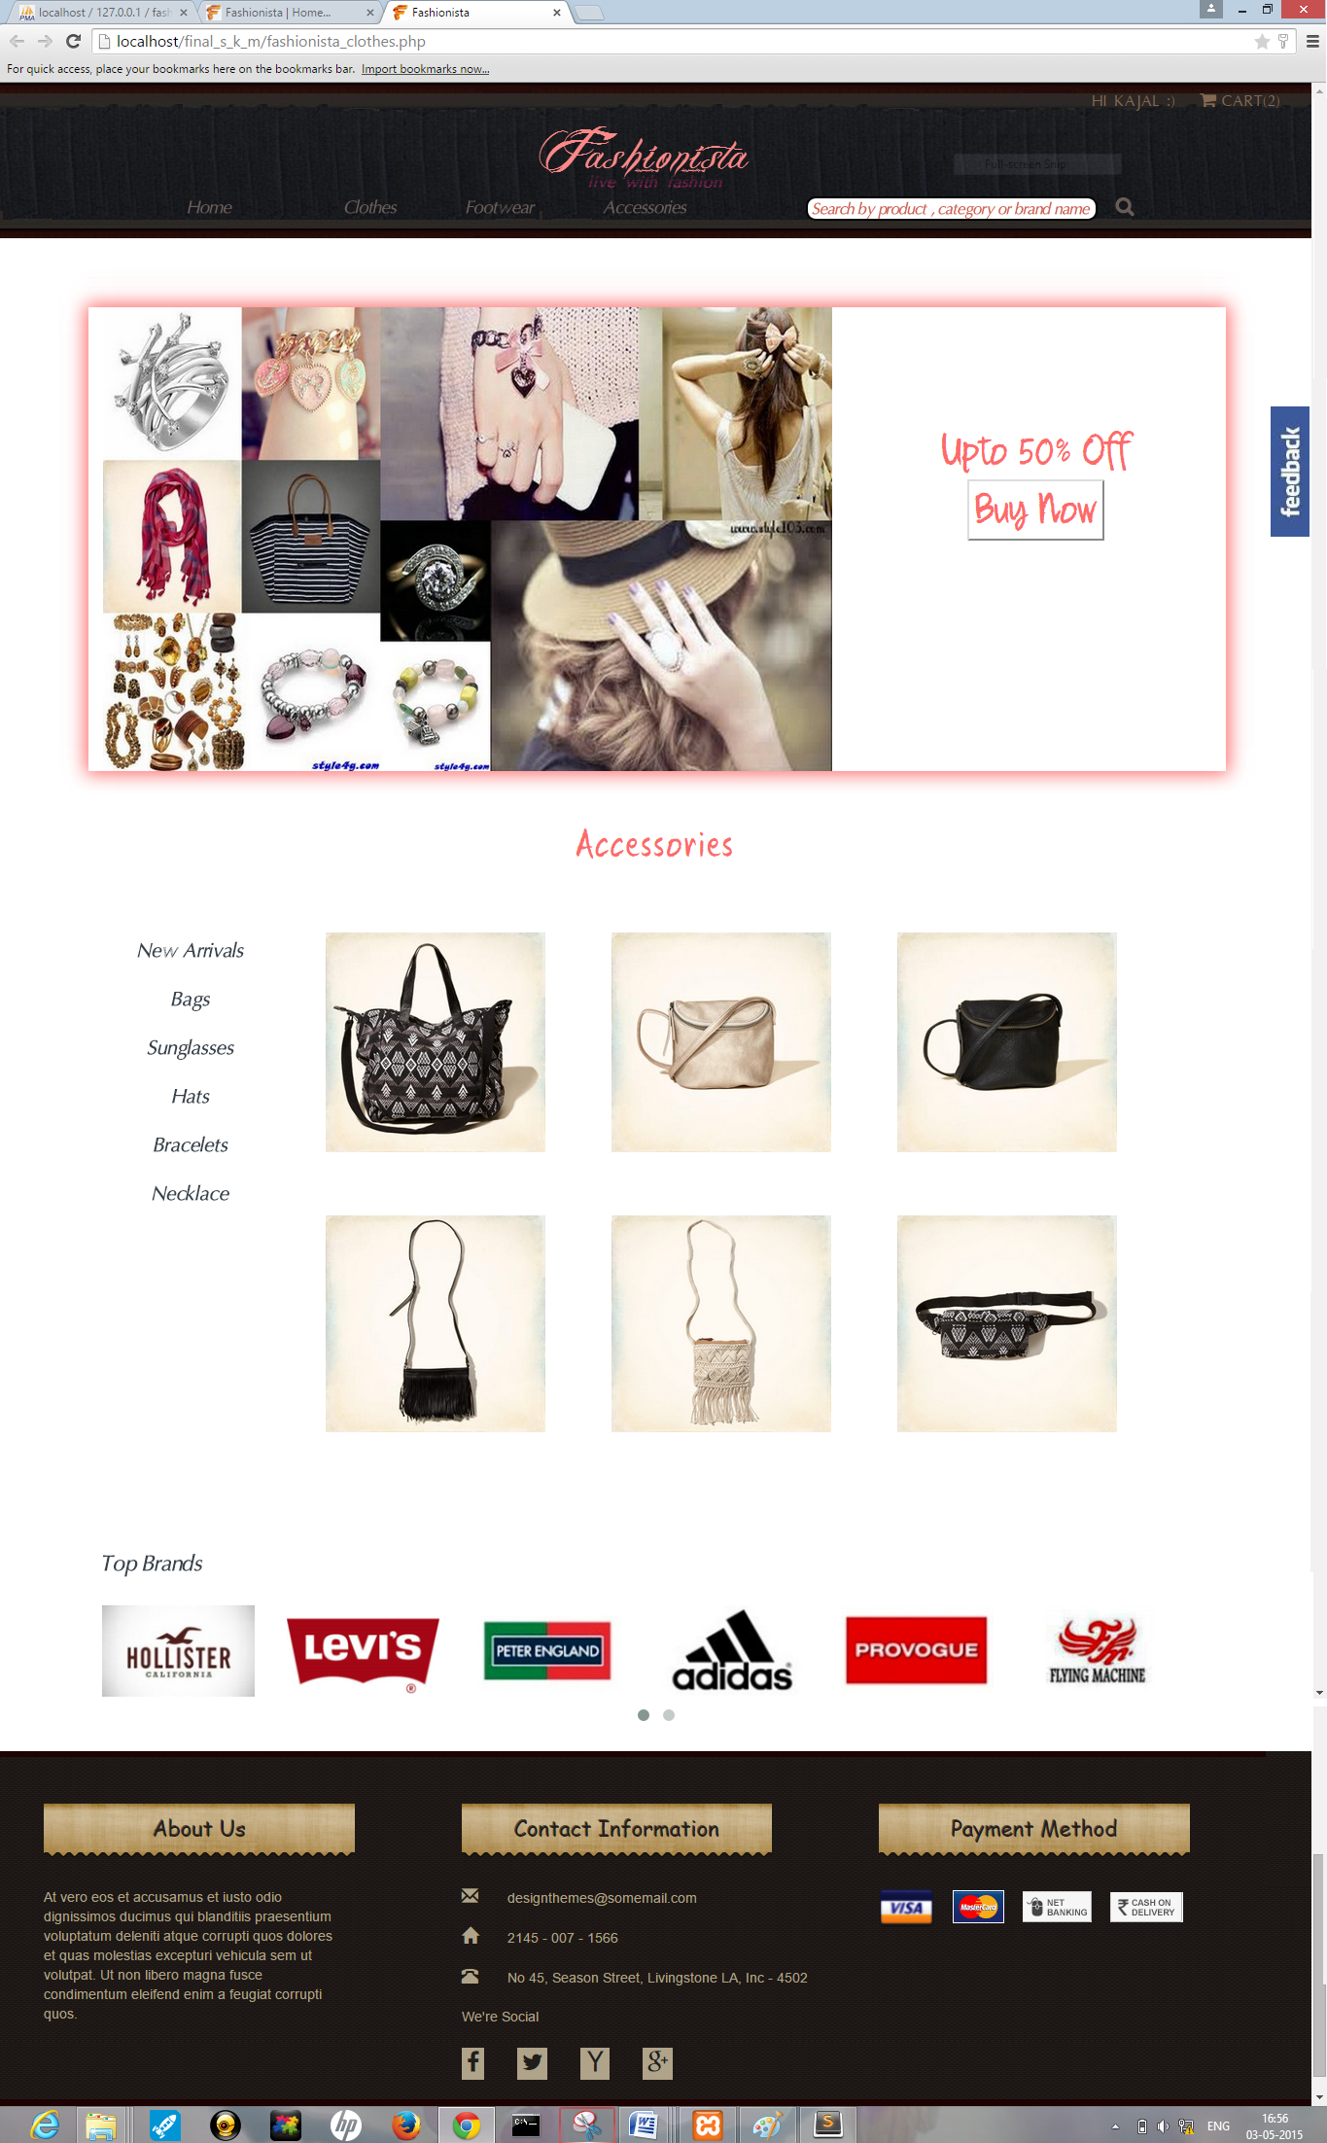

**5.1.8 PRODUCT DESCRIPTION**

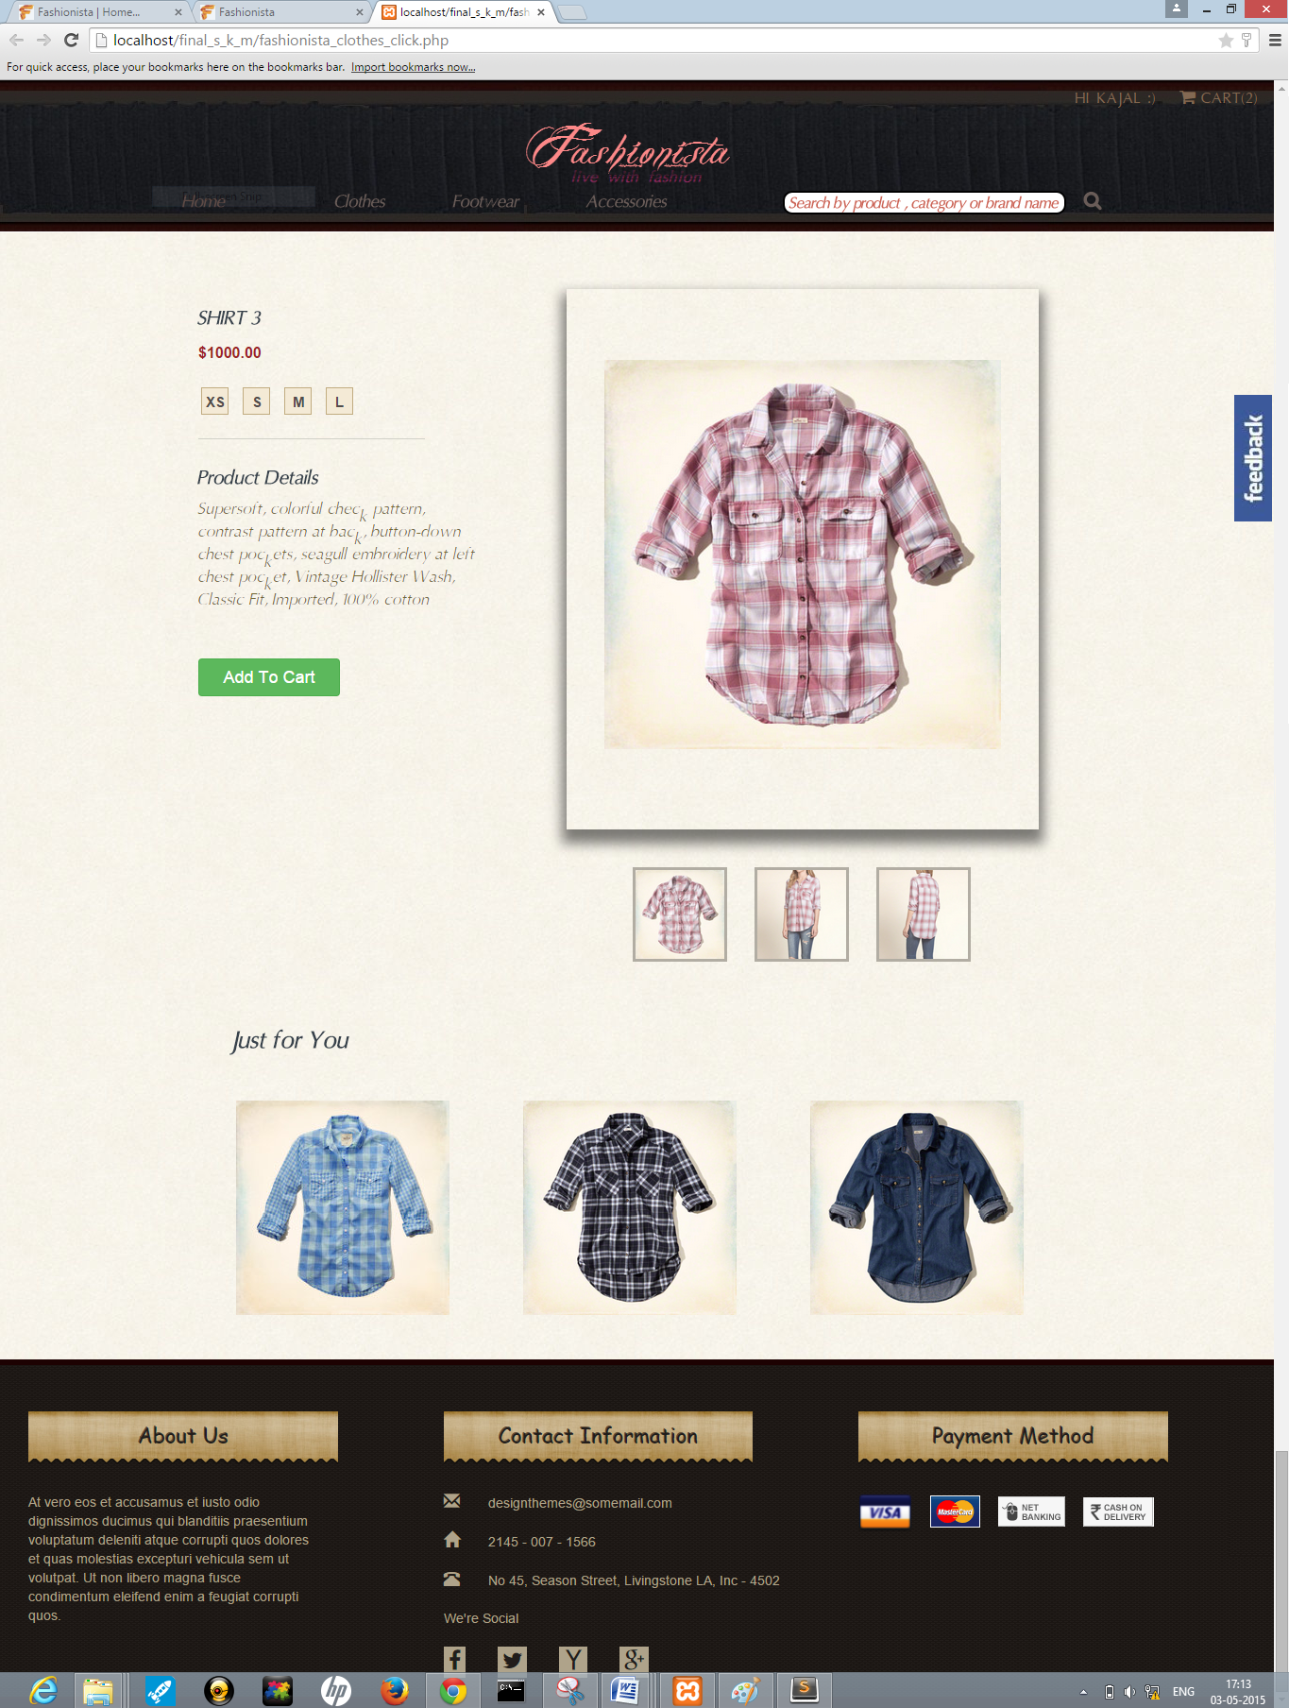

**5.1.9 ADD TO CART**

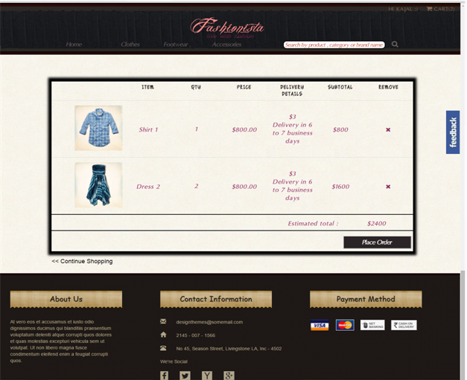

**5.1.10 PLACE ORDER**

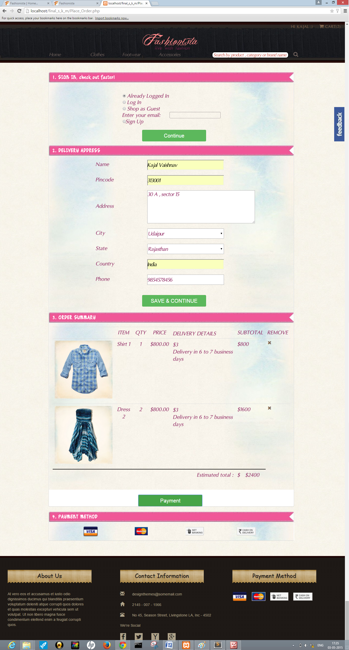

**5.1.11 SEARCH PRODUCT**

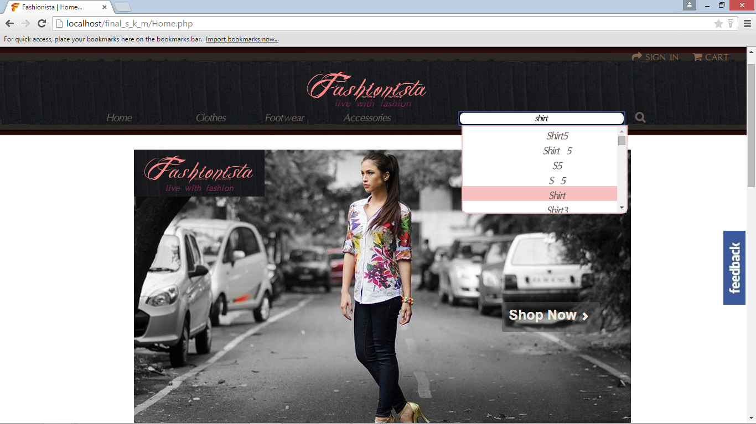

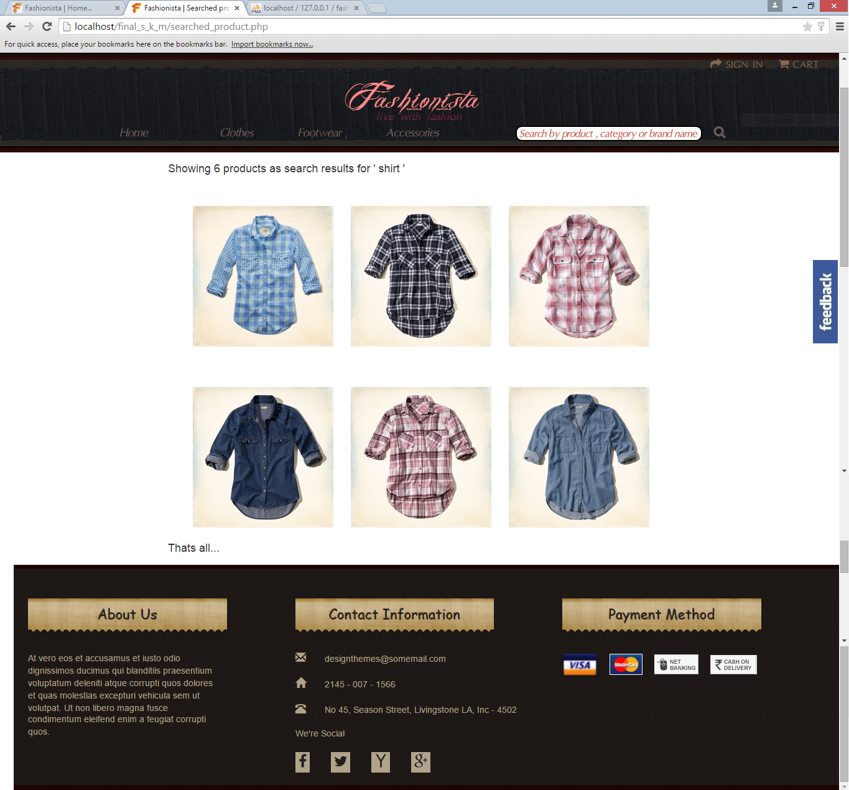

**5.1.12 FEEDBACK**

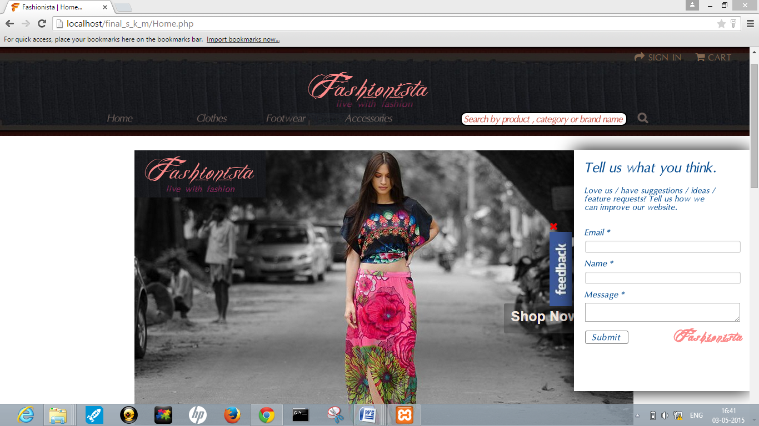

**5.1.13 ADMIN PANEL**

**5.1.13.1 ADD CATEGORY**

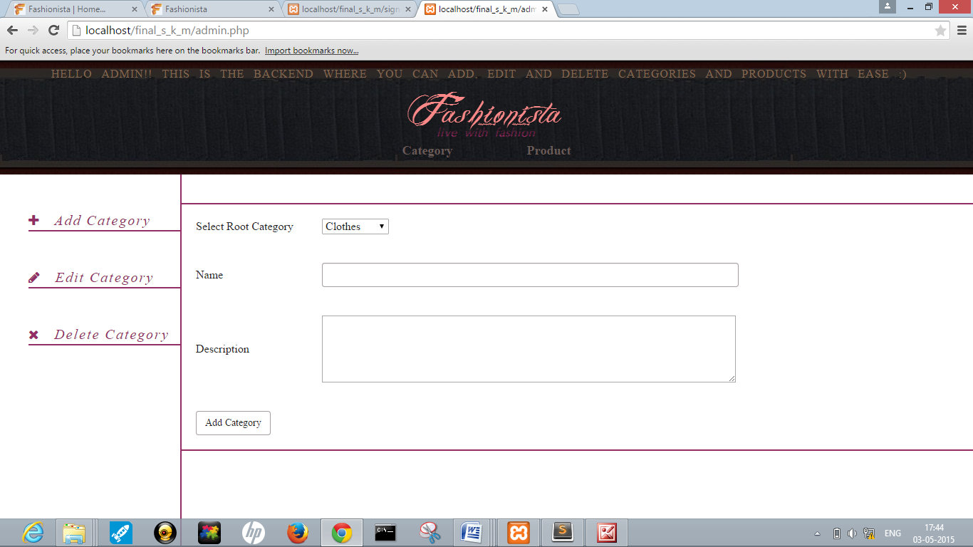

**5.1.13.2 EDIT CATEGORY**

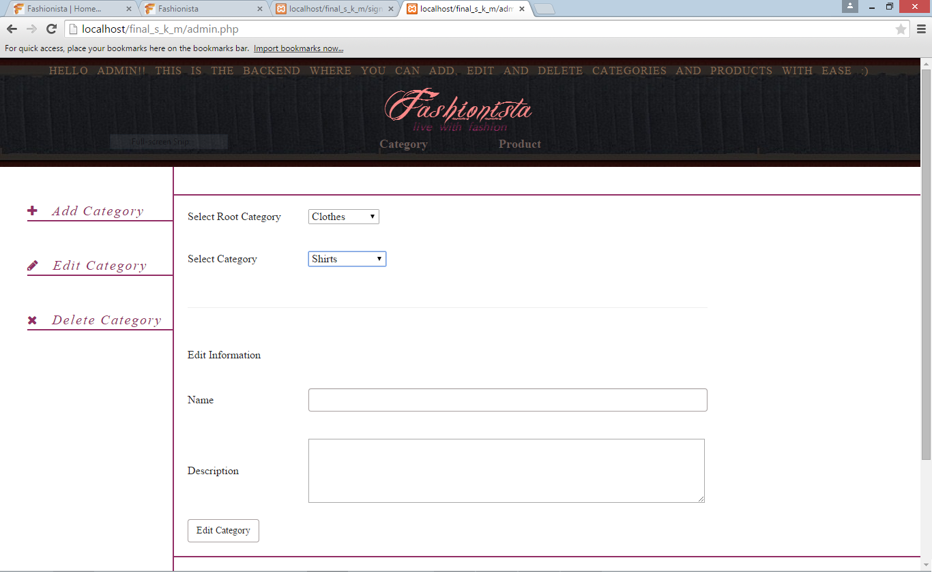

**5.1.13.3 DELETE CATEGORY**

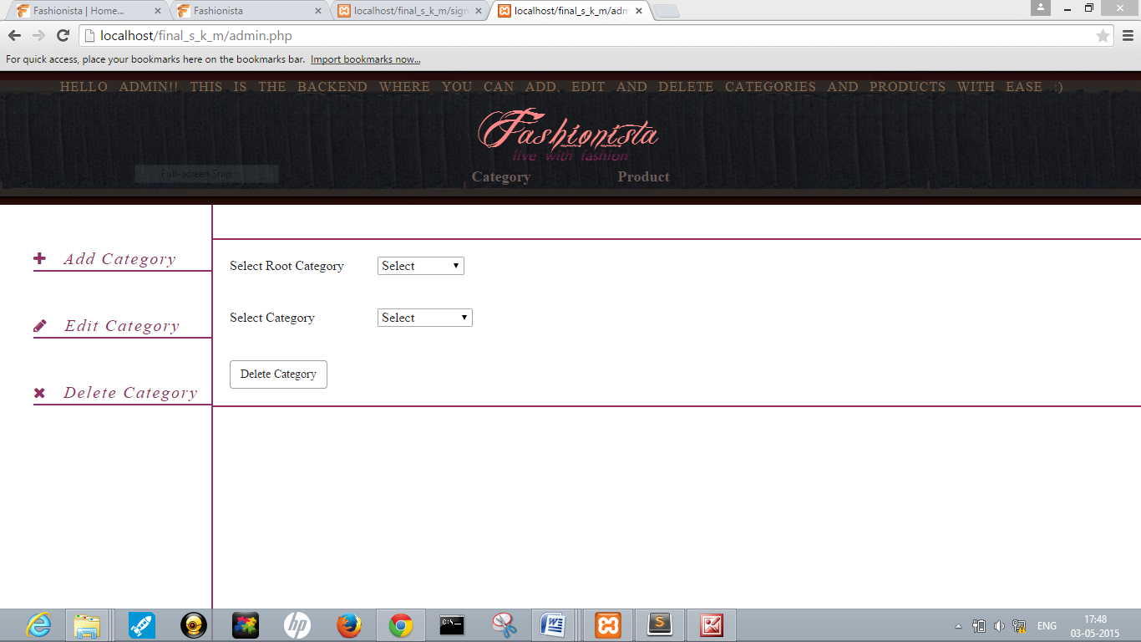

**5.1.13.4 ADD NEW PRODUCT**

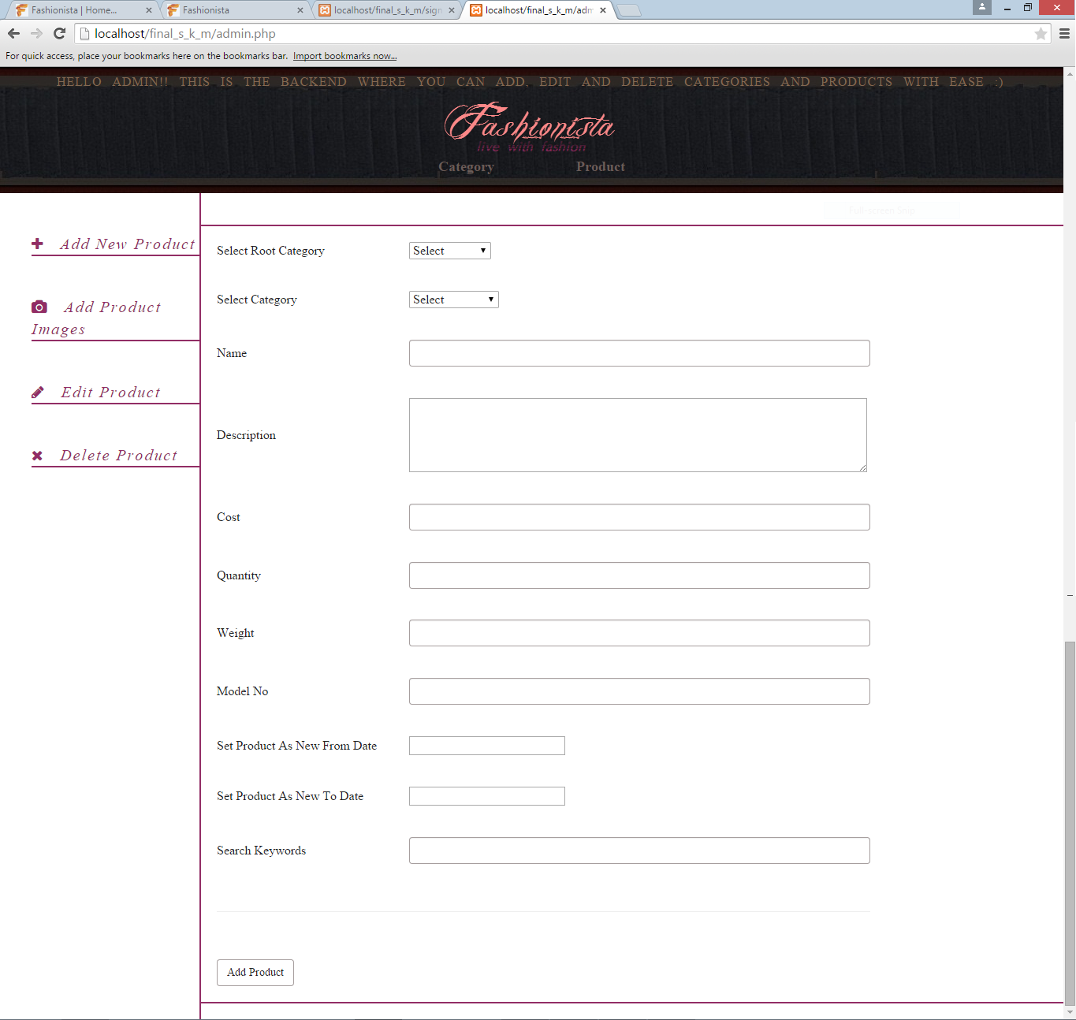

**5.1.13.5 ADD PRODUCT IMAGES**

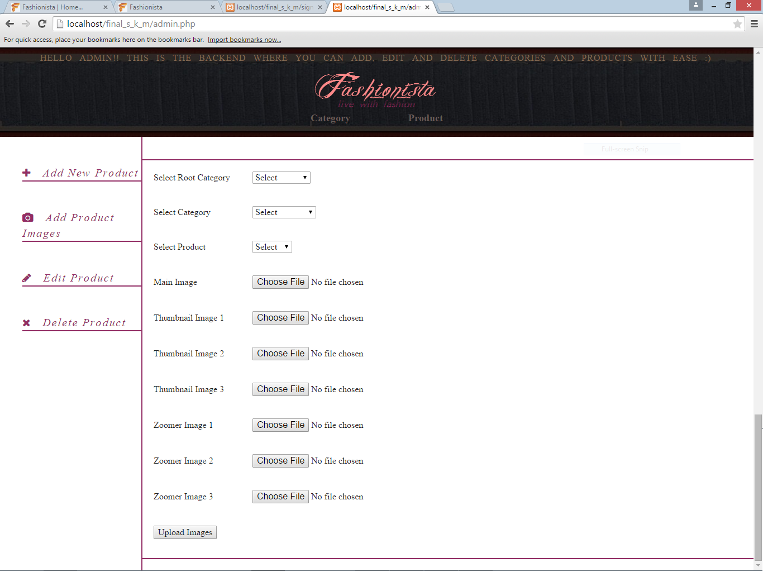

**Code for Uploading Images:**

The form posts the image to the admin side.

<form action='admin.php' method='post' enctype="multipart/form-data">

<input type = 'file' id='m_image' name='m_image'/>

</form>

At the admin,

if(isset($_POST['upload_image']))

{

$m_image_name=$_FILES['m_image']['name'];

$tmp_name=$_FILES['m_image']['tmp_name'];

$path='uploads/';

move_uploaded_file($tmp_name, $path.$m_image_name);

}

**5.1.13.6 EDIT PRODUCT**

**5.1.13.6.1. EDIT PRODUCT INFORMATION**

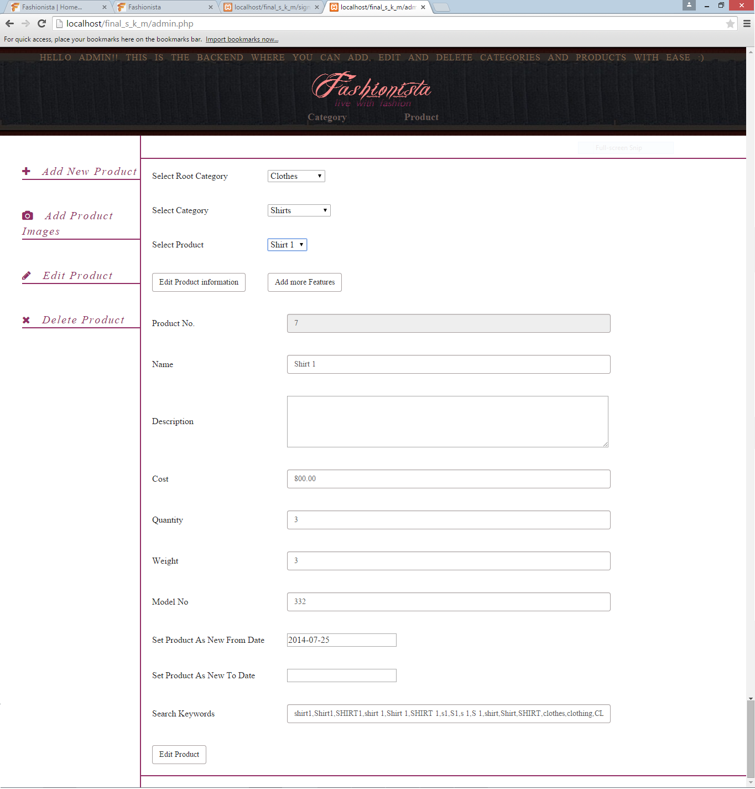

**5.1.13.6.2. ADD MORE FEATURES**

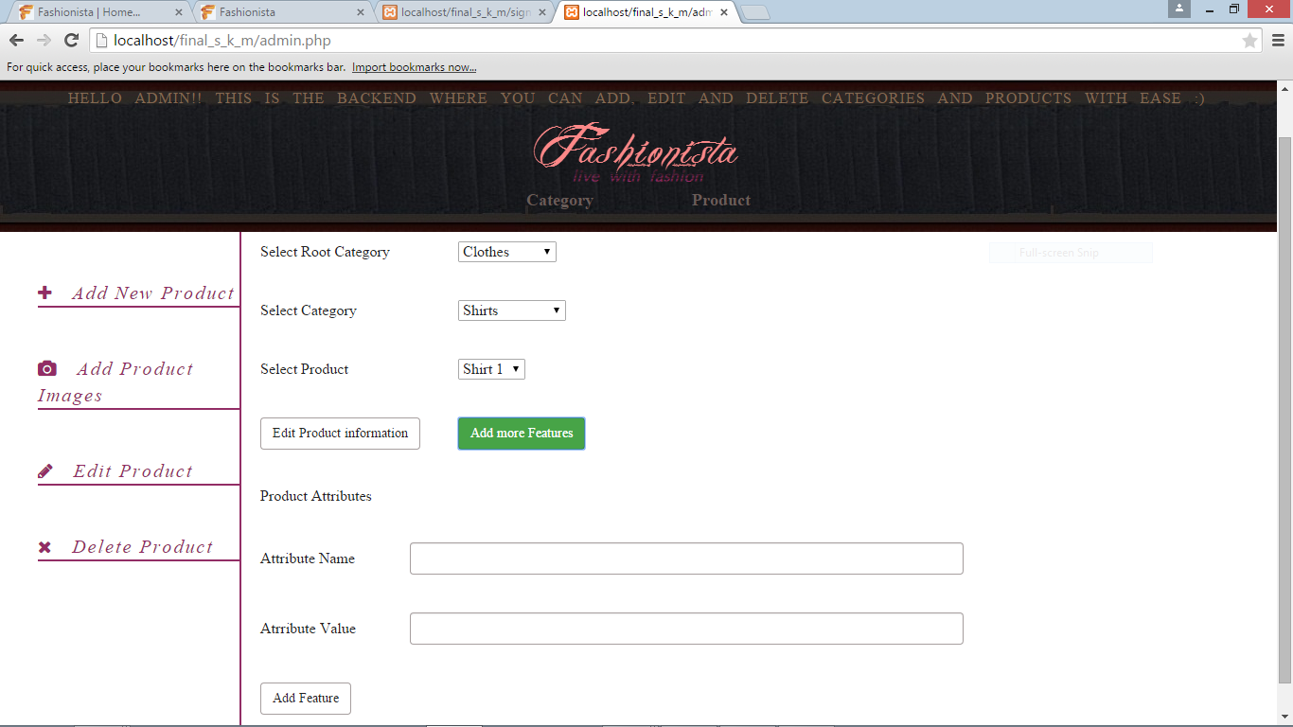

**5.1.13.7 DELETE PRODUCT**

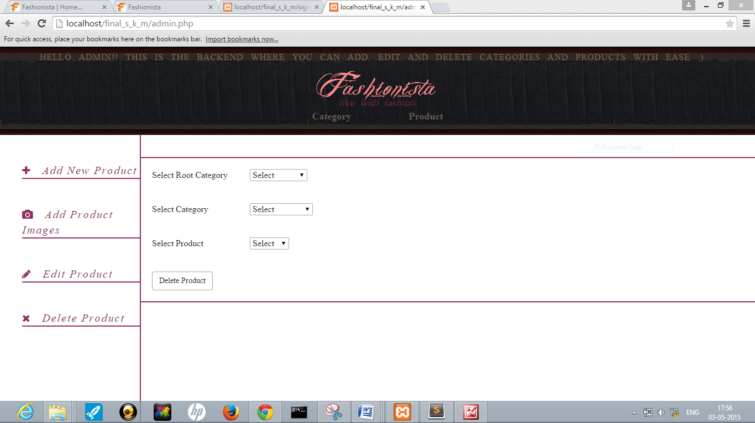

**5.2 DATABASE TABLES**

**Code for Database Connectivity:**

**dbconnection.php**

class DBConnect provides the following:

$connection: object representing MySQL connection.

sql_update(): performs update and insert queries.

sql_select(): performs select queries.

<?php

require_once('config.php');

class DBConnect{

private $connection;

function __construct()

{

global $config;

$this->connection=mysqli_connect($config['DBHOST'],$config['USER'],$config['PASS'],$config['DBNAME']);

}

function sql_update($query){

if(mysqli_query($this->connection,$query))

{

return true;

}

else return false;

}

function sql_select($query){

return mysqli_query($this->connection,$query);

}

function sql_close(){

mysqli_close($this->connection);

}

}

?>

**config.php provides the necessary database information:**

<?php

$config['DBHOST']='localhost';

$config['USER']='root';

$config['PASS']='';

$config['DBNAME']='fashionista';

?>

**Creating objects:**

<?php

require_once('dbconnection.php');

$obj = new DBConnect();

?>

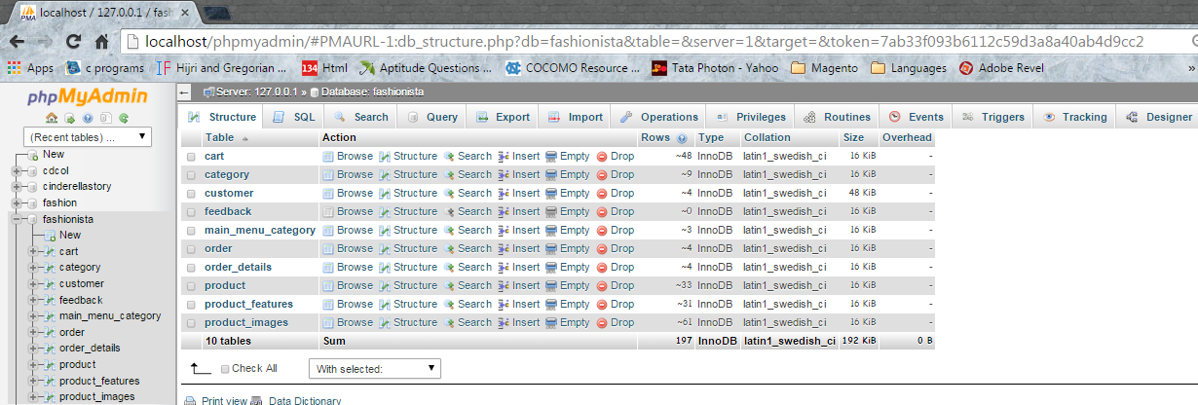

**5.2.1 main_menu_category table**

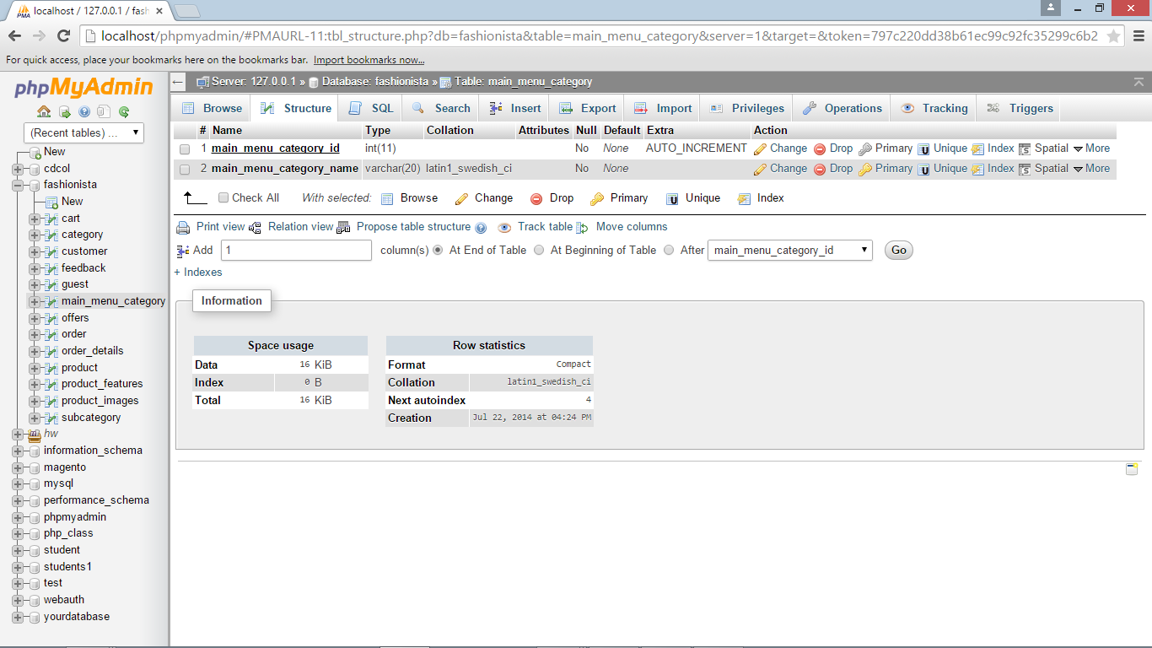

**5.2.2 category table**

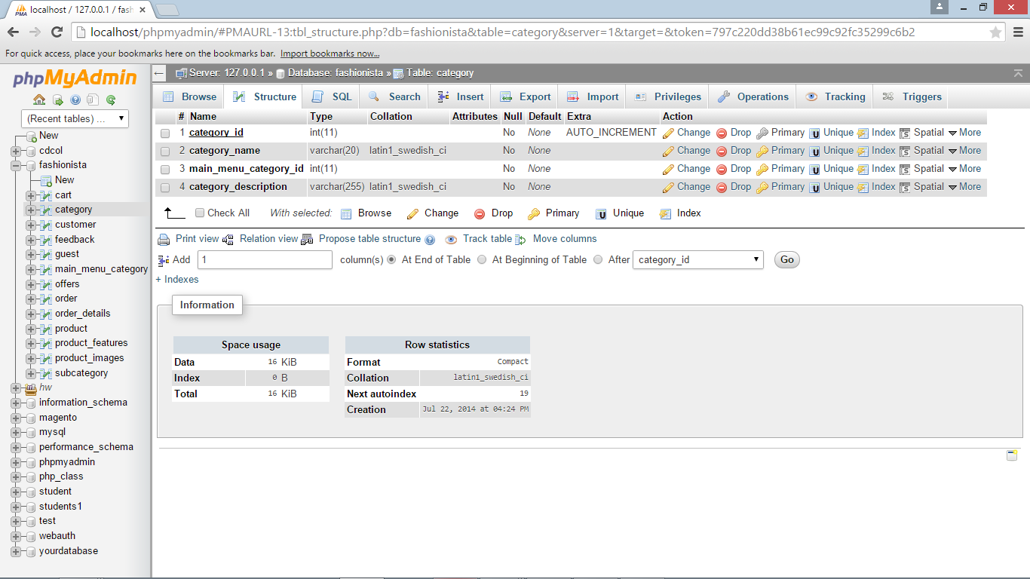

**5.2.3 product table**

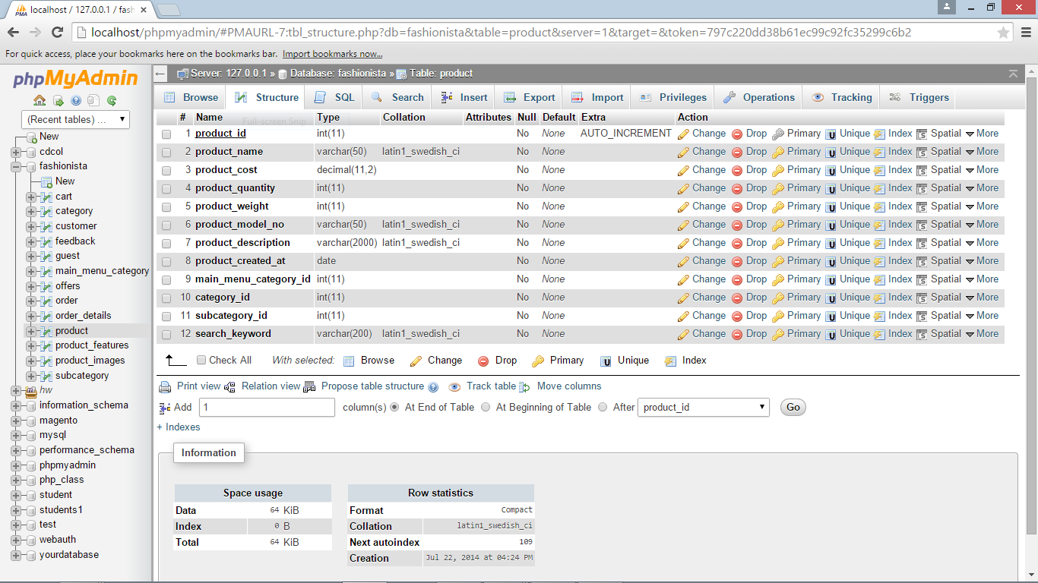

**5.2.4 product_images table**

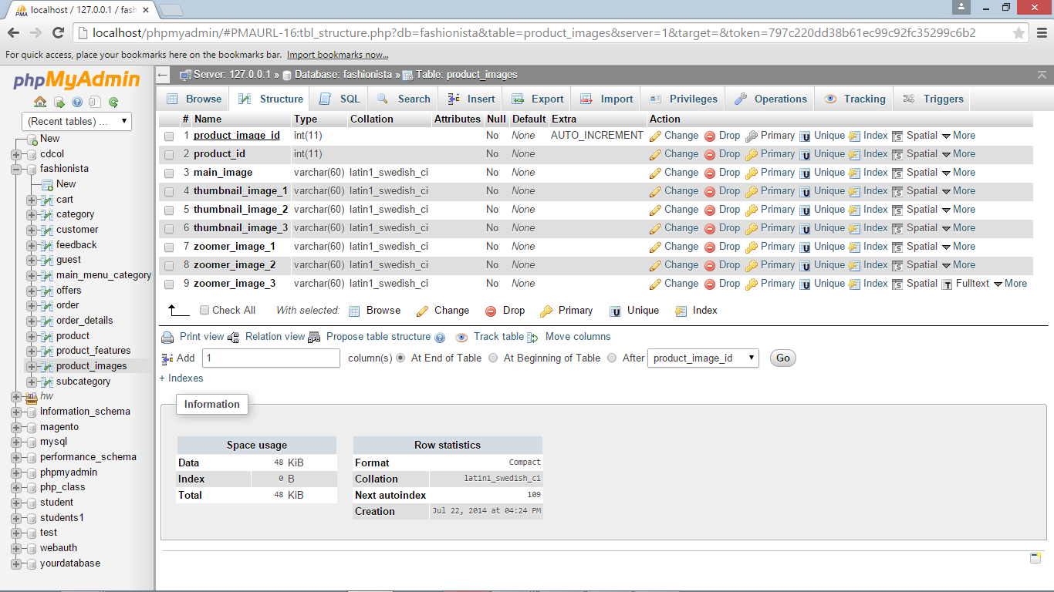

**5.2.5 product_features table**

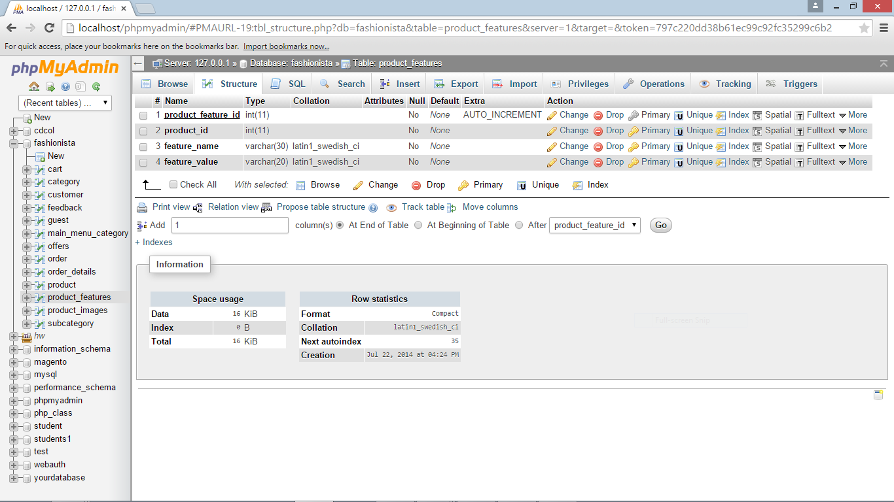

**5.2.6 customer table**

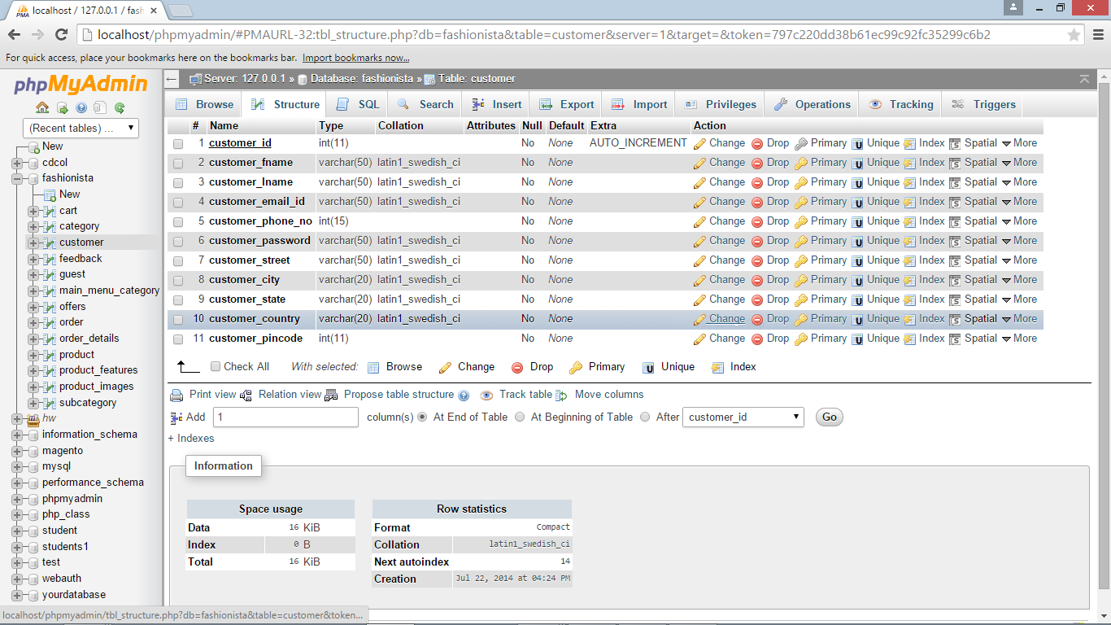

**5.2.7 order table**

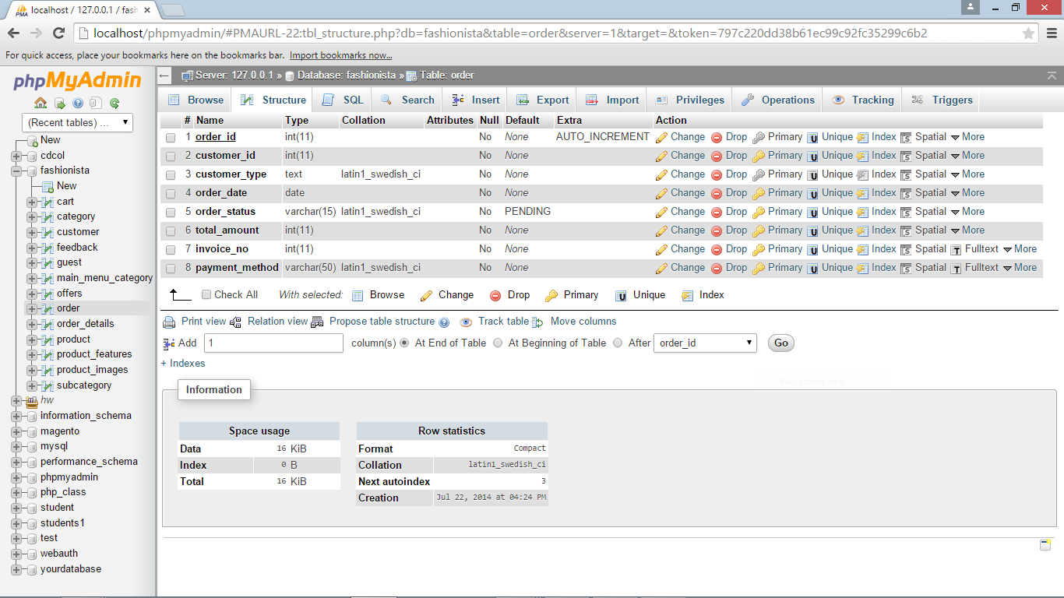

**5.2.8 order_details table**

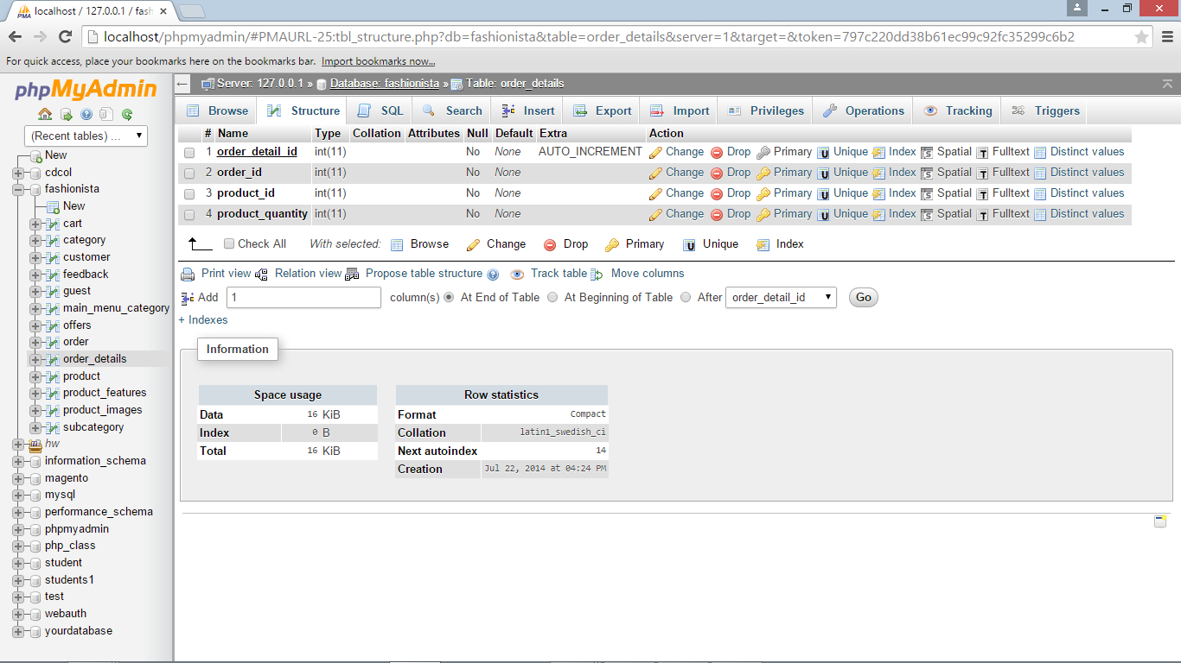

**5.2.9 cart table**

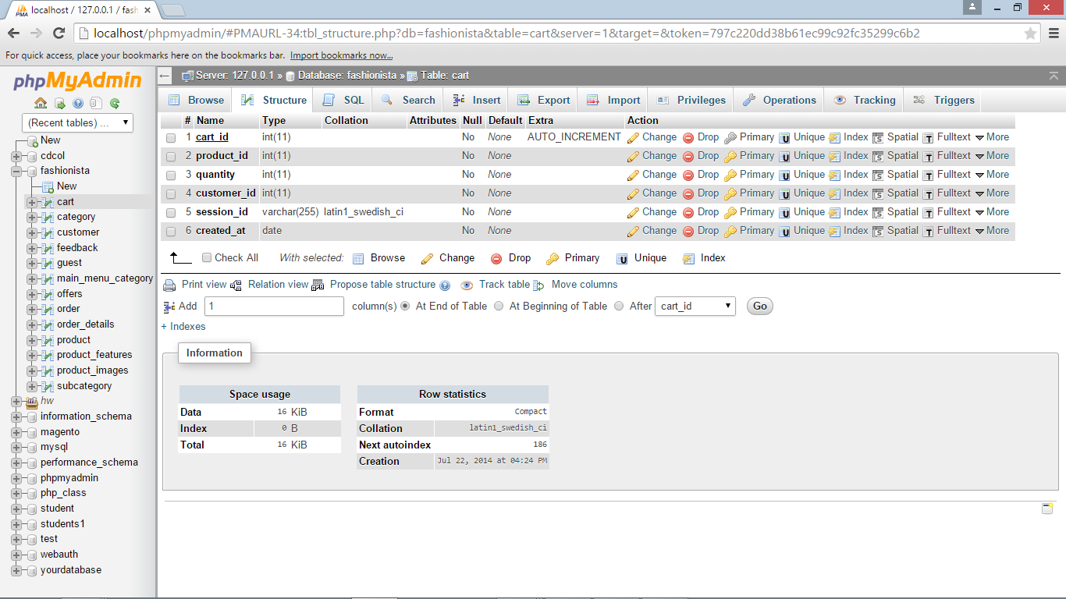

**5.2.10 feedback table**

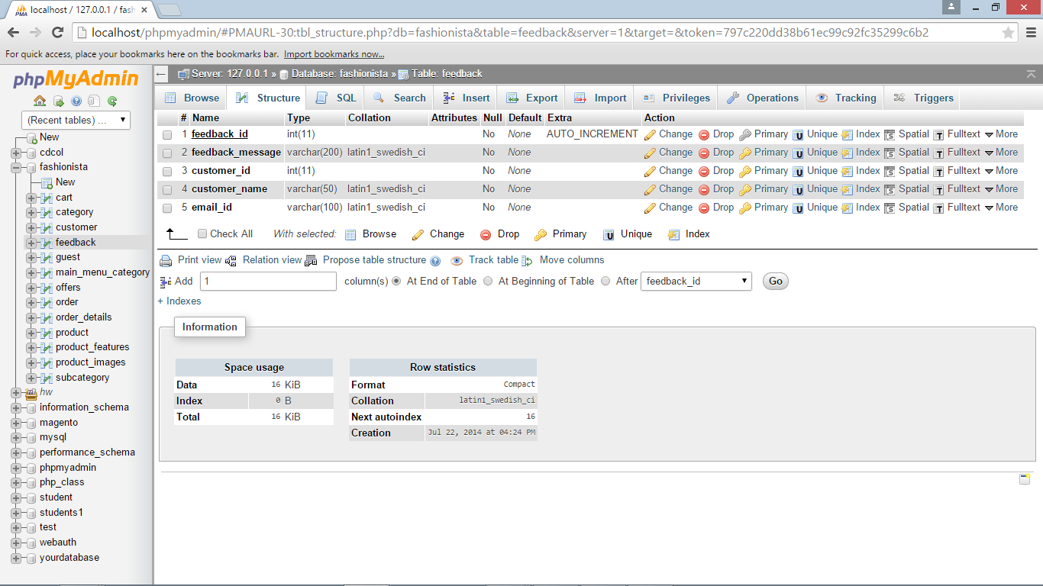

**CHAPTER 6 - CONCLUSION AND FUTURE SCOPE**

**6.1 CONCLUSION**

It has been a great pleasure for me to work on this exciting and challenging project. This project proved good for me as it provided practical knowledge of not only programming in PHP and MySQL, but also about all handling procedure related with “Online Shopping System”. It also provides knowledge about the latest technology used in developing web enabled application and client server technology that will be great demand in future. This will provide better opportunities and guidance in future in developing projects independently.

**6.2 FUTURE SCOPE**

* This System being web-based and an undertaking of Cyber Security Division, needs to be thoroughly tested to find out any security gaps.
* Database with higher security could be implemented.
* The facility of payment at the client side and of monitoring orders at the backend can be added.
* The option of adding Main Menu categories can be provided which can help scaling the website to a bigger level.

**CHAPTER 7 – REFERENCES**

1. Steven Suehring, Janet Valade, “PHP, MySQL, JavaScript & HTML5 All-in-One For Dummies”, *ISBN 978-1-118-21370-4*, John Wiley & Sons, Inc.,2013
2. http://www. www.w3schools.com/ as cited on 21st May 2014.
3. http://www.getbootstrap.com/ as cited on 25th May 2014.
4. http://www.tutorialspoint.com/sql as cited on 30th May 2014.
5. https://jquery.com/ as cited on 2nd June 2014.
6. https://www.safaribooksonline.com/library/view/high-performance-mysql/ as cited on 5th June 2014
7. http://www.javonicwebsoft.com/ as cited on 20th June 2014